Author of the week: Roger Penrose

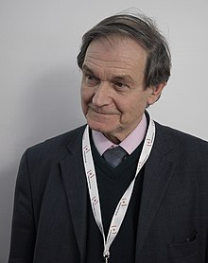

The British mathematician and physicist, Sir Roger Penrose (born 1931), made striking and original contributions to the study of geometry, relativity, quantum mechanics, and the human mind. Roger Penrose was born in Colchester, England, on August 8, 1931. His father was the geneticist Lionel Penrose, an expert on mental defects, whose interest in geometry was passed on to his son. The Penrose family was illustrious in British intellectual life in the 20th century. Jonathan Penrose won the British chess championship ten times in the 1950s and 1960s. It is not surprising that the intellectual life of the Penrose household was lively. Penrose received his undergraduate degree from University College, London, and then proceeded to Cambridge for his doctorate. While an undergraduate he discovered a theorem, concerning conic sections from which some of the basic theorems of projective geometry follow as special cases. As part of his work for his doctorate, he rediscovered some important results in the theory of matrices.
“Understanding is, after all, what science is all about and science is a great deal more than mindless computation.” - Roger Penrose

Awards & Achievements

- Adams Prize (1966)
- Dannie Heineman Prize for Mathematical Physics (1971)
- Eddington Medal (1975),
- Royal Medal (1985),
- Wolf Prize in Physics (1988),
- Dirac Medal of the Institute of Physics (1989),
- Albert Einstein Medal (1990)
- Naylor Prize and Lectureship (1991),
- Dirac Medal for the Advancement of Theoretical Physics (2006), and
- Nobel Prize in Physics (2020)

List of books by Roger Penrose
(Available in the library)

1 | 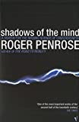 | Title: Shadows of the mind : a search for the missing science of consciousness  Author: Penrose, Roger  Publisher: London: Vintage, 1995  Call No.: 153.4 PEN  Acc. No.: 014346
2 | 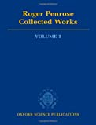 | Title: Roger Penrose: collected works. volume 1-6  Author: Penrose, Roger  Publisher: Oxford: Oxford University Press, 2010  Call No.: 510 PEN  Acc. No.: 026501-026505, 026401
3 | 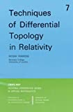 | Title: Techniques of differential topology in relativity  Author: Penrose, Roger.  Publisher: Philadelphia: Siam, 1972  Call No.: 530.11 PEN  Acc. No.: 026214
4 | 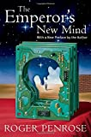 | Title: Emperor`s new mind : concerning computers, minds and the laws of physics  Author: Penrose, Roger.  Publisher: Oxford: Oxford University Press, 1999  Call No.: 006.3 PEN  Acc. No.: 014348
5 | 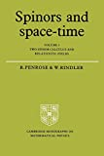 | Title: Spinors and space time; v. 1: two-spinor calculus and relativistic fields  Author: Penrose, Roger.  Publisher: Cambridge: Cambridge University Press, 1984  Call No.: 530.11 PEN  Acc. No.: 026263
6 | 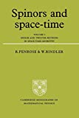 | Title: Spinors and space-time; v. 2: Spinor and Twistor methods in space-time geometry  Author: Penrose, Roger.  Publisher: Cambridge: Cambridge University Press, 1988  Call No.: 530.11 PEN  Acc. No.: 026262
7 | 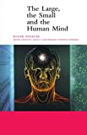 | Title: Large, the small and the human mind  Author: Penrose, Roger.  Publisher: Cambridge: Cambridge University Press, 2000  Call No.: 530.1 PEN  Acc. No.: 025956
8 | 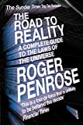 | Title: Road to reality: a complete guide to the laws of the universe  Author: Penrose, Roger.  Publisher: New Delhi: Penguin Books, 2005  Call No.: 530.1 PEN  Acc. No.: 023346
9 | 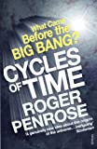 | Title: Cycles of time: an extraordinary new view of the universe  Author: Penrose, Roger.  Publisher: London: Vintage Books, 2010  Call No.: 523.1 PEN  Acc. No.: 025804
10 | 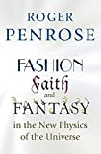 | Title: Fashion, faith, and fantasy in the new physics of the universe  Author: Penrose, Roger.  Publisher: Princeton: Princeton University Press, 2016  Call No.: 530.01 PEN  Acc. No.: 025806
11 | 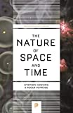 | Title: Nature of space and time  Author: Hawking, Stephen and Penrose, Roger.  Publisher: Princeton: Princeton University Press, 2015  Call No.: 530.11 HAW  Acc. No.: 022779

Articles by and on Roger Penrose:-

- PENROSE, R. (1991). The Emperor's New Mind. RSA Journal, 139(5420), 506-514. October 26, 2020, retrieved from http://www.jstor.org/stable/41378098
- Penrose, R. (1992). On the Cohomology of Impossible Figures. Leonardo, 25(3/4), 245-247. doi:10.2307/1575844
- Penrose, R. (1955). A generalized inverse for matrices. Mathematical Proceedings of the Cambridge Philosophical Society, 51(3), 406-413. doi:10.1017/S0305004100030401
- Davis, M. (1993). How subtle is Gödel's theorem? More on Roger Penrose. Behavioral and Brain Sciences, 16(3), 611-612. doi:10.1017/S0140525X00031915
Web Resources on Roger Penrose:-

- Kruglinski, Susan (2009). Roger Penrose Says Physics Is Wrong, From String Theory to Quantum Mechanics. Discover Magazine, retrieved from: https://www.discovermagazine.com/the-sciences/discover-interview-roger-penrose-says-physics-is-wrong-from-string-theory

- Nobel Media (2020). Roger Penrose Interview. The Nobel Prize in Physics, retrieved from: https://www.nobelprize.org/prizes/physics/2020/penrose/interview/

- Khanna, Gaurav (2020). Nobel Prize in physics awarded for work on black holes – an astrophysicist explains the trailblazing discoveries. The Conversation, retrieved from: https://theconversation.com/2020-nobel-prize-in-physics-awarded-for-work-on-black-holes-an-astrophysicist-explains-the-trailblazing-discoveries-147614

- Paulson, Steve (2017). Roger Penrose on why consciousness does not compute. Nautilus, retrieved from: http://nautil.us/issue/47/consciousness/roger-penrose-on-why-consciousness-does-not-compute

- Mitra, Debkumar (2020). Roger Penrose - the man with an eye for beauty and a Physics Nobel. The Economic Times, retrieved from: https://economictimes.indiatimes.com/news/international/world-news/view-roger-penrose-the-man-with-an-eye-for-beauty-and-a-physics-nobel/articleshow/78613119.cms

- Amos, Jonathan (2020). Sir Roger Penrose: The man who proved black holes weren't 'impossible'. BBC News, retrieved from: https://www.bbc.com/news/science-environment-54439150

Video
- Pioneer Works (2020). 2020 Nobel Prize Winner Sir Roger Penrose in Conversation with Janna Levin. YouTube, retrieved from: https://www.youtube.com/watch?v=xi_auG9R-Wo

- Perimeter Institute for Theoretical Physics (2020). Q&A with 2020 Nobel laureate Roger Penrose. YouTube, retrieved from: https://www.youtube.com/watch?v=fQPUYjoG5jI

- Closer to truth (2020). Roger Penrose - Is Mathematics Invented or Discovered? YouTube, retrieved from: https://www.youtube.com/watch?v=ujvS2K06dg4

- Fridman, Lex (2020). Roger Penrose: Physics of Consciousness and the Infinite Universe. YouTube, retrieved from: https://www.youtube.com/watch?v=orMtwOz6Db0

Compiled by Library on
27.10.2020

