Author of the Week: C. V. Raman
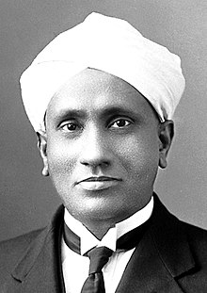

C.V. Raman, in full Sir Chandrasekhara Venkata Raman, (born November 7, 1888, Trichinopoly, India—died November 21, 1970, Bangalore), Indian physicist whose work was influential in the growth of science in India. He was the recipient of the Nobel Prize for Physics in 1930 for the discovery that when light traverses a transparent material, some of the light that is deflected changes in wavelength. This phenomenon is now called Raman scattering and is the result of the ‘Raman Effect’.
Awards and Honours :-
- In 1924, he was elected as a Fellow of the Royal Society early in his career and was knighted in 1929.
- He won the Nobel Prize in Physics in 1930.
- He was awarded the Franklin Medal in 1941.
- He was awarded the Bharat Ratna in 1954, the highest civilian award in India.
- In 1957, he was awarded the Lenin Peace Prize.
- The American Chemical Society and the Indian Association for the Cultivation of Science in 1998 recognized Raman's discovery as an International Historic Chemical Landmark.
- On 28 February every year, India celebrates National Science Day to commemorate the discovery of the Raman Effect in 1928 in his honour.
In 1970, he received a major heart attack while working in the laboratory. He took his last breath in the Raman Research Institute on 21st November, 1970.

Books on C V Raman
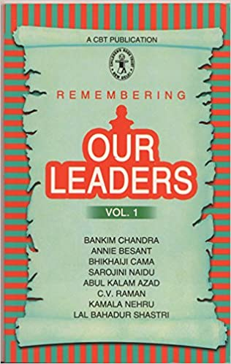 | Title: Remembering our leaders. vol. 1  Author: CBT  Publisher: New Delhi: Childrens Book Trust, 1989  Call No.: 954.0350924 REM  Acc. No.: CC0478
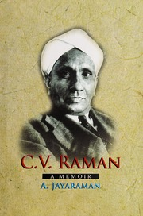 | Title: C. V. Raman: a memoir  Author: Jayaraman, A.  Publisher: Bengaluru: Indian Academy of Science, 2017  Call No.: 530.092 JAY  Acc. No.: 025648
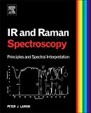 | Title: Infrared And Raman Spectroscopy; Principles And Spectral Interpretation  Author: Larkin, Peter  Publisher: Boston: Elsevier, 2011  Call No.: 535.842 LAR  Acc. No.: 010545 - 010546
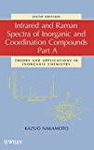 | Title: Infrared and Raman spectra of inorganic and coordination compounds, Part A  Author: Nakamoto, Kazuo  Publisher: Hoboken: John Wiley & Sons, 2009  Call No.: 543.57 NAK  Acc. No.: 003655
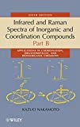 | Title: Infrared and Raman spectra of inorganic and coordination compounds,Part B  Author: Nakamoto, Kazuo  Publisher: Hoboken: John Wiley & Sons, 2009  Call No.: 543.57 NAK  Acc. No.: 003656
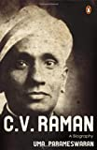 | Title: C.V. Raman : a biography  Author: Parmeshwaran, Uma  Publisher: New Delhi: Penguing Books, 2011  Call No.: 530.0924 PAR  Acc. No.: 010204
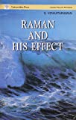 | Title: Raman and his effect  Author: Venkatraman, G.  Publisher: Hyderabad: Universities Press, 1992  Call No.: 535.84619 VEN  Acc. No.: 004813

Some relevant web-resources on C. V. Raman:-
- C.V. Raman and his work
http://dspace.rri.res.in/handle/2289/1466
- C V Raman and the American Scientists
https://insa.nic.in/writereaddata/UpLoadedFiles/IJHS/Vol38_2_5_RSingh.pdf
- C.V. Raman and image building through media
https://vigyanprasar.gov.in/isw/CVRaman-and-image-building-through-media.html
- C V Raman discovered the ‘Raman effect’
http://nobelprizeseries.in/tbis/cv-raman
- C. V. Raman and the Discovery of the Raman Effect Physics in Perspective volume 4, pages399–420(2002)
https://link.springer.com/article/10.1007/s000160200002
- Chandrasekharavenkata Raman – a memoir
https://www.ias.ac.in/public/Resources/Other_Publications/e-Publications/003/Chandrasekhara_Venkata_Raman.pdf
- ACS (2020). C.V. Raman and the Raman Effect: International Historic Chemical Landmark. American Chemical Society, retrieved from: https://www.acs.org/content/acs/en/education/whatischemistry/landmarks/ramaneffect.html
- Editors, Famous Scientists (2020). C. V. Raman. Famous Scientists, retrieved from: https://www.famousscientists.org/c-v-raman/
- Editors, Encyclopedia Britannica (2020). C.V. Raman: Indian Physicist. Encyclopedia Britannica, retrieved from: https://www.britannica.com/biography/C-V-Raman
- Indian Academy of Sciences (1988). C.V. Raman: A Pictorial Biography. Arvhive.org, retrieved from https://archive.org/details/cvramanpictorial00bang/mode/2up
- Nobelprize (1930). Sir Chandrasekhara Venkata Raman – Biographical. NobelPrize.org. Nobel Media AB 2020. Fri. 6 Nov 2020. Retrieved from: https://www.nobelprize.org/prizes/physics/1930/raman/biographical/

Complied by Library
09.11.2020

