Author of the week: Subrahmanyan Chandrasekhar

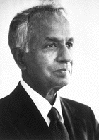

(19th October 1910 to 21st August 1995)

Subrahmanyan Chandrasekhar was one of the foremost astrophysicists of the twentieth century. He was one of the first scientists to couple the study of physics with the study of astronomy. Chandra proved that there was an upper limit to the mass of a white dwarf. This limit, known as the Chandra limit, showed that stars more massive than the Sun would explode or form black holes as they died. Chandra also developed theories on star atmospheres, black holes, and the illumination of the sunlit sky, star structures and star mass. In 1983, Chandrasekhar was awarded the Nobel Prize in Physics for his work on the physical processes involved in the structure and evolution of stars. Chandra published ten books and served as the editor of the prominent Astrophysical Journal for nineteen years. In 1999, four years after his death in August of 1995, NASA launched Chandra, a x-ray observatory named in honor of Subrahmanyan Chandrasekhar. The observatory studies the universe in the x-ray portion of the electromagnetic spectrum.
“Science is a perception of the world around us. Science is a place where what you find in nature pleases you..”– Subrahmanyan Chandrasekhar

Awards & Achievements

- Bruce Medal (1952),
- Gold Medal of the Royal Astronomical Society (1953),
- Henry Draper Medal (1971),
- Nobel Prize in Physics (1983),
- Royal Medal (1962),
- Copley Medal (1984),
- Henry Norris Russell Lectureship (1949),
- Padma Vibhushan (1968)

List of books by Subrahmanyan Chandrasekhar
(Available in the library)

1 | 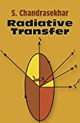 | Title: Radiative transfer  Author: Chandrasekhar, S.  Publisher: New York: Dover, 1960  Call No.: 523.0133 CHA  Acc. No.: 010086
2 | 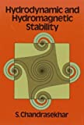 | Title: Hydrodynamic and hydromagnetic stability  Author: Chandrasekhar, S.  Publisher: New York: Dover Publication, 1961  Call No.: 532.5 CHA  Acc. No.: 011576
3 | 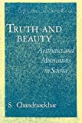 | Title: Truth and beauty: aesthetics and motivations in science  Author: Chandrasekhar, S.  Publisher: Chicago: University of Chicago Press, 1987  Call No.: 530.01 CHA  Acc. No.: 016908
4 | 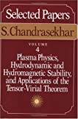 | Title: Plasma physics, hydrodynamic and hydromagnetic stability, and applications of the tensor-virial theorem  Author: Chandrasekhar, S.  Publisher: Chicago: University Of Chicago Press, 1989  Call No.: 523.01 CHA  Acc. No.: 016113
5 | 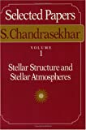 | Title: Stellar structure and stellar atmospheres  Author: Chandrasekhar, S.  Publisher: Chicago: University of Chicago Press, 1989  Call No.: 523.01 CHA  Acc. No.: 016115
6 | 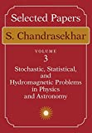 | Title: Stochastic, statistical, and hydromagnetic problems in physics and astronomy  Author: Chandrasekhar, S.  Publisher: Chicago: University of Chicago Press, 1989  Call No.: 523.01 CHA  Acc. No.: 015548
7 | 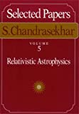 | Title: Relativistic astrophysics  Author: Chandrasekhar, S.  Publisher: Chicago: University of Chicago Press, 1990  Call No.: 523.01 CHA  Acc. No.: 016114
8 | 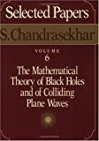 | Title: Mathematical theory of black holes and of colliding plane waves  Author: Chandrasekhar, S.  Publisher: Chicago: University of Chicago Press, 1991  Call No.: 523.01 CHA  Acc. No.: 016116
9 | 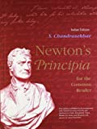 | Title: Newton`s Principia for the common reader  Author: Chandrasekhar, S.  Publisher: New Delhi Oxford University Press 1995  Call No.: 531 CHA  Acc. No.: 016795
10 | 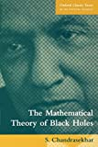 | Title: Mathematical theory of black holes  Author: Chandrasekhar, S.  Publisher: New Delhi Oxford University Press 1998  Call No.: 523 CHA  Acc. No.: 016796
11 | 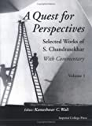 | Title: quest for perspectives : selected works of S. Chandrasekhar  Author: Chandrasekhar, S.  Publisher: London Imperial College Press 2001  Call No.: 523.01 CHA  Acc. No.: 014121 - 014122
12 | 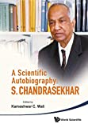 | Title: Scientific autobiography: S. Chandrasekhar  Author: Chandrasekhar, S.  Publisher: Singapore: World Scientific, 2010  Call No.: 523.01092 CHA  Acc. No.: 014119
List of books on Subrahmanyan Chandrasekhar
13 | 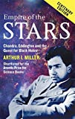 | Title: Empire of the stars : friendship, obsession and betrayal in the quest for black holes  Author: Miller, Arthur I.  Publisher: London: Abacus, 2005  Call No.: 523.8875 MIL  Acc. No.: 013968
14 | 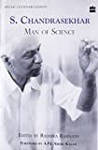 | Title: S. Chandrasekhar : man of science  Author: Ramnath, Radhika.  Publisher: New Delhi: Harper Collins Publishers India, 2011  Call No.: 523.01092 RAM  Acc. No.: 008372
15 | 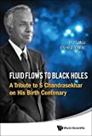 | Title: Fluid flows to black holes : A tribute to s. chandrasekhar on his birth centenary  Author: Saikia, D. J.  Publisher: Singapore: World Scientific, 2011  Call No.: 523.01 SAI  Acc. No.: 014120
16 | 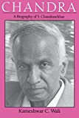 | Title: Chandra : a biography of S. Chandrasekhar ​  Author: Wali, Kameshwar C.  Publisher: Chicago: University Of Chicago Press, 1991  Call No.: 523.01092 WAL  Acc. No.: 013962
17 | 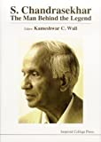 | Title: S. Chandrasekhar : the man behind the legend  Author: Wali, K. C.  Publisher: London: Imperial College Press, 1997  Call No.: 523.01092 WAL  Acc. No.: 014123

Web Resources on Subrahmanyan Chandrasekhar:-

- Guide to the Subrahmanyan Chandrasekhar Papers 1913-2011
https://www.lib.uchicago.edu/e/scrc/findingaids/view.php?eadid=ICU.SPCL.CHANDRASEKHAR

- NobelPrize.org. . Subramanyan Chandrasekhar – Biographical. Nobel Media AB 2020, retrieved from: https://www.nobelprize.org/prizes/physics/1983/chandrasekhar/biographical/

- Parker, Eugene N. (2020). SUBRAHMANYAN CHANDRASEKHAR: October 13, 1910–August 21, 1995. Biographical Memoirs: V.72,The National Academies of Science Engineering Medicine, retrieved from: https://www.nap.edu/read/5859/chapter/4

- Sreenivasan, Katepalli R. Chandrasekhar’s Fluid Dynamics Annual Review of Fluid Mechanics retrieved from https://www.annualreviews.org/doi/pdf/10.1146/annurev-fluid-010518-040537

- Editors of Encyclopaedia Britannica (2020). Subrahmanyan Chandrasekhar. Encyclopædia Britannica, retrieved from: https://www.britannica.com/biography/Subrahmanyan-Chandrasekhar

- Express Web Desk (2017). Who was S Chandrasekhar? The Indian Express, retrieved from: https://indianexpress.com/article/who-is/who-is-subrahmanyan-chandrasekhar-nobel-prize-winner-physics-4897568/

- Famous Scientists (2020). Subrahmanyan Chandrasekhar, retrieved from: https://www.famousscientists.org/subrahmanyan-chandrasekhar/ .

- Oral History Interviews that offer unique insights into the lives, works, and personalities of modern scientists
https://www.aip.org/history-programs/niels-bohr-library/oral-histories/4551-1

- Subrahmanyan Chandrasekhar Bibliography
http://www.phys-astro.sonoma.edu/BruceMedalists/Chandrasekhar/index.html

Video
- NDTV Profit (2014). Great Indians: Professor Subrahmanyan Chandrasekhar. Retrieved from: https://www.ndtv.com/video/shows/great-indians/great-indians-professor-subrahmanyan-chandrasekhar-305874

Compiled by Library
on 21.10.2020

