**Author of the Week**

**CHITRA BANERJEE DIVAKARUNI**

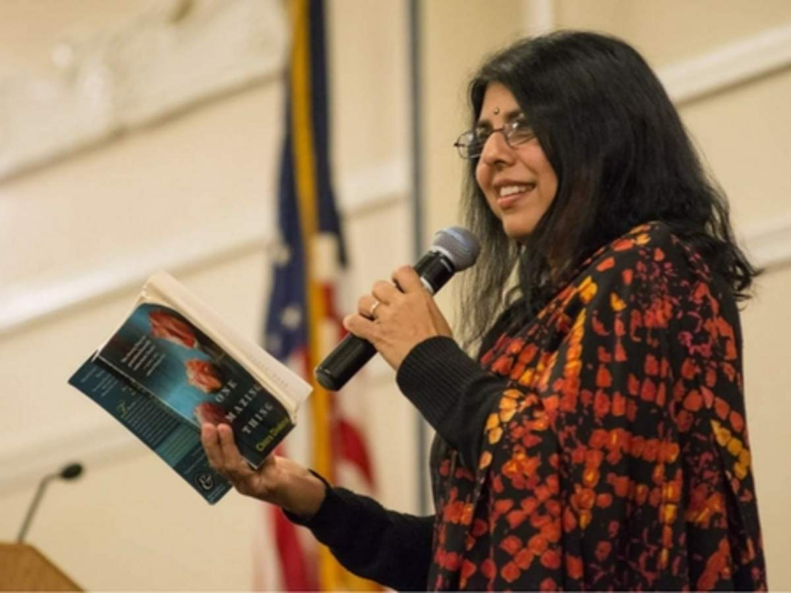

Chitra Banerjee Divakaruni born in Kolkata, India, she went to the United States for her graduate studies, receiving a Master’s degree in English from Wright State University in Dayton, Ohio, and a Ph.D. from the University of California, Berkeley.

Chitra Banerjee Divakaruni is an award winning and bestselling author, poet, activist and teacher of writing. Her work has been published in over 50 magazines, including the Atlantic Monthly and The New Yorker, and her writing has been included in over 50 anthologies, including The Best American Short Stories, the O.Henry Prize Stories and the Pushcart Prize Anthology. Her books have been translated into 29 languages, including Dutch, Hebrew, Bengali, Russian and Japanese, and many of them have been used for campus-wide and city-wide reads. Several of her works have been made into films and plays.

**List of books by Chitra Banerjee Divakaruni**

|  |  |  |
| --- | --- | --- |
| Sr.No. | Book Cover | Bibliography Details |
| 1. | **C:\Users\acer\AppData\Local\Temp\Rar$DIa20780.36479\OneAmazing+PB.jpg** | **Title:** One amazing thing **Author:** Divakaruni, Chitra Banerjee **Publisher:** Penguin Books, 2010 **Call No.:** 813.54 DIV **Acc. No.:** 009590 |
| 2. | C:\Users\acer\AppData\Local\Temp\Rar$DIa20780.39208\The Palace.jpg | Title: Palace of illusions: a novel  Author: Divakaruni, Chitra Banerjee Publisher: Picador India 2008 Call No.: 813.54 DIV Acc. No.: 009599 |
| 3. | **C:\Users\acer\AppData\Local\Temp\Rar$DIa20780.43318\conch+bearer.jpg** | **Title:** The Conch bearer  **Author:** Divakaruni, Chitra Banerjee **Publisher:** India Links Roli Books, 2003 **Call No.:** 823.92 DIV **Acc. No.:** 010018 |
| 4. | **C:\Users\acer\AppData\Local\Temp\Rar$DIa20780.48883\The unknown errors of our lives.jpg** | Title: The unknown errors of our lives: stories Author: Divakaruni, Chitra Banerjee Publisher: Anchor Books, 2002 Call No.: 813.54 DIV Acc. No.: 010023 |
| 5. | **C:\Users\acer\AppData\Local\Temp\Rar$DIa20780.1527\The lives of strangers.jpg** | **Title:** The lives of strangers **Author:** Divakaruni, Chitra Banerjee **Publisher:** Abacus, 2005 **Call No.:** 813.54 DIV **Acc. No.:** 010211 |
| 6. | **C:\Users\acer\AppData\Local\Temp\Rar$DIa20780.4098\leaving-yuba-city.jpg** | Title: Leaving Yuba City: new and selected poems Author: Divakaruni, Chitra Banerjee Publisher: Knopf Publishing Group, 1997 Call No.: 811.54 DIV Acc. No.: 010624 |
| 7. | **C:\Users\acer\AppData\Local\Temp\Rar$DIa20780.5970\Mirror of fire and dreaming.jpg** | **Title:** Mirror of fire and dreaming: the brotherhood of the Conch : Book II **Author:** Divakaruni, Chitra Banerjee **Publisher:** Roaring Brook Press, 2005 **Call No.:** 823 DIV **Acc. No.:** 011276 |
| 8. | **C:\Users\acer\AppData\Local\Temp\Rar$DIa20780.9401\arranged-marriage-chitra-banerjee-divakaruni.jpg** | **Title:** Arranged marriage: stories **Author:** Divakaruni, Chitra Banerjee **Publisher:** Black Swan, 1997 **Call No.:** 813.54 DIV **Acc. No.:** 011536 |
| 9. | **C:\Users\acer\AppData\Local\Temp\Rar$DIa20780.11936\The Mistress Of Spices.jpg** | **Title:** The Mistress of Spices **Author:** Divakaruni, Chitra Banerjee **Publisher:** Orient Paperbacks, 1997 **Call No.:** 823.914 DIV **Acc. No.:** 011541 |
| 10. | **C:\Users\acer\AppData\Local\Temp\Rar$DIa20780.15215\Queen of dreams.jpg** | **Title:** Queen of dreams **Author:** Divakaruni, Chitra Banerjee **Publisher:** Abacus, 2005 **Call No.:** 813.54 DIV **Acc. No.:** 011600 |
| 11. | **C:\Users\acer\AppData\Local\Temp\Rar$DIa20780.25079\Sister of my heart.jpg** | **Title:** Sister of my heart **Author:** Divakaruni, Chitra Banerjee **Publisher:** Anchor Books, 2000 **Call No.:** 813.54 DIV **Acc. No.:** 011601 |
| 12. | **C:\Users\acer\AppData\Local\Temp\Rar$DIa20780.6125\Vine of desire.jpg** | **Title:** Vine of desire: a novel **Author:** Divakaruni, Chitra Banerjee **Publisher:** Abacus, 2003 **Call No.:** 813.54 DIV **Acc. No.:** 012591 |

**Articles Links on Chitra Banerjee Divakaruni**

1. *Chitra Divakaruni*. (n.d.). Chitra Banerjee Divakaruni.

<http://www.chitradivakaruni.com>

1. *Foundation, P.* (2020, August 6). *Chitra Banerjee Divakaruni . Poetry Foundation; Poetry Foundation.*

<https://www.poetryfoundation.org/poets/chitra-banerjee-divakaruni>

1. *Books by Chitra Banerjee Divakaruni and Complete Book Reviews. (n.d.). PublishersWeekly.Com.*

<https://www.publishersweekly.com/pw/authorpage/chitra-banerjee-divakaruni.html>

1. *Divakaruni, C. B. (2000, March 1). Uncertain Objects of Desire. The Atlantic.* <https://www.theatlantic.com/magazine/archive/2000/03/uncertain-objects-of-desire/306672/>
2. *Priyadershini S.* (2013, February 14). *Strength of a woman. The Hindu.* <https://www.thehindu.com/features/metroplus/strength-of-a-woman/article4414930.ece>
3. *Pawar, B. S. (2019). Research Monograph Series.* 5(3), 16.

<https://philarchive.org/archive/PAWDFA>

1. *Gunasundari, V. (2019, April). Chitra Banerjee Divakaruni’s literary works: A Review. 7.*

<https://www.ijmra.us/project%20doc/2019/IJRSS_APRIL2019/IJMRA-15396.pdf>

1. *Children’s Bookshelf talks with Chitra Banerjee Divakaruni*. (2005, October 20). Publishers Weekly.Com.

<https://www.publishersweekly.com/pw/by-topic/authors/interviews/article/21706-children-s-bookshelf-talks-with-chitra-banerjee-divakaruni.html>

**Videos Links:**

1. Chitra Banerjee Divakaruni at Kolkata Literary Meet 2019. (2019, February 12). [Video file]. <https://www.youtube.com/watch?v=UZrn3BuUN8w>
2. 2017 Mansfield Reads with Chitra Banerjee Divakaruni. (2017, May 17). [Video file]. <https://www.youtube.com/watch?v=3n7o052ClK8>
3. You Are the Pride: Chitra Divakaruni. (2010, March 9). [Video file]. <https://www.youtube.com/watch?v=MYyR-Uj72bA>
4. UCF Global Perspectives—Chitra Divakaruni. (2009, May 12). [Video file]. <https://www.youtube.com/watch?v=e1lSxMycOlQ>
5. The Reluctant Patriot. Los Angeles Times- Chitra Divakaruni. (2001, October 21). [Video file]. <https://www.latimes.com/archives/la-xpm-2001-oct-21-op-59757-story.html>
6. The Mistress of Spices Hollywood movie. (2019, April 16). [Video file]. <https://www.youtube.com/watch?v=fDrOjZgyy4E>
7. *Interview with Chitra Banerjee Divakaruni by Sharin and Anuya I Author of Forest of Enchantments*. (2019, February 6). [Video file]. Retrieved August 7, 2020, from <https://www.youtube.com/watch?v=IZiOn3s0mMo>

**Compiled by Library**

**Date: 14.08.2020**