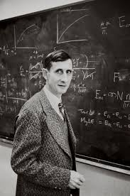
Freeman John Dyson FRS (15 December 1923 – 28 February 2020) was an English-born American theoretical physicist and mathematician known for his work in quantum electrodynamics, solid-state physics, astronomy and nuclear engineering. He was professor emeritus in the Institute for Advanced Study in Princeton, a member of the Board of Visitors of Ralston College and a member of the Board of Sponsors of the Bulletin of the Atomic Scientists. Dyson died at a hospital near Princeton, New Jersey, on 28 February 2020 at age 96 from complications following a fall.

Author of the week: Freeman Dyson

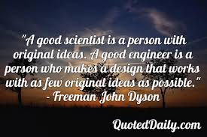

Links:
- https://en.wikipedia.org/wiki/Freeman_Dyson
- https://www.sns.ias.edu/dyson

Sr.No. | Book Image | Bibliography Details
1. | 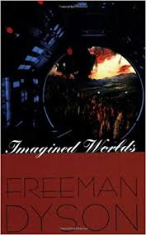 | Title: Imagined Worlds  Author: Dyson, Freeman  Publisher: Cambridge: Harvard University Press, 1998  Call No.: 081 DYS  Acc. No.: 022663
2. | 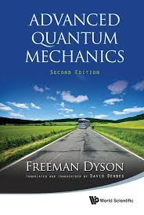 | Title: Advanced quantum mechanics  Author: Dyson, Freeman  Publisher: Singapore: World Scientific Publishing, 2011  Call No.: 530.12 DYS  Acc. No.: 027456
3. | 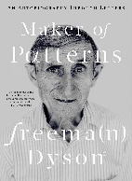 | Title: Maker of patterns : an autobiography through letters  Author: Dyson, Freeman  Publisher: New York: Liveright Publishing Corporation, 2018  Call No.: 530.092 DYS  Acc. No.: 028132

Date: 1.03.2020

