**Author of the Week: Steven Weinberg**

Steven Weinberg was born in 1933 in **New York City** to **Frederick and Eva Weinberg**. His early inclination was toward science, which received encouragement from his father, and by the time he was 15 or 16 his interests had focused on **theoretical physics**. He received undergraduate degree from **Cornell** in 1954, and then went for a year of graduate study to the **Institute for Theoretical Physics in Copenhagen** (now the Niels Bohr Institute). There, with the help of **David Frisch and Gunnar Källén**, he began to do research in physics. Weinberg then returned to the U.S. to complete his graduate studies at Princeton. His **Ph.D thesis**, with **Sam Treiman** as adviser, was on the application of renormalization theory to the effects of strong interactions in weak interaction processes.

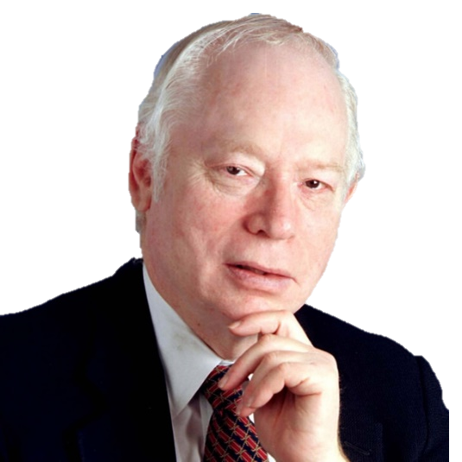

After receiving Ph.D. in 1957, he worked at **Columbia** and then from **1959 to 1966** at Berkeley. Steven’s research during this period was on a wide variety of topics – **high-energy behaviour of Feynman graphs, second-class weak interaction currents, broken symmetries, scattering theory, muon physics**, etc. – topics chosen in many cases because he was trying to teach himself some area of physics. Weinberg’s active interest in **astrophysics** dates from 1961-62; wrote some papers on the cosmic population of neutrinos and then began to write a book, **Gravitation and Cosmology**, which was eventually completed in 1971. Late in 1965, he began his work on **current algebra** and the application to the strong interactions of the idea of spontaneous **symmetry breaking**.

From 1966 to 1969, on leave from Berkeley, Steven Weinberg was **Loeb Lecturer** at **Harvard** and then **visiting professor** at **M.I.T.** In 1969, he accepted a professorship in the Physics Department at M.I.T., then chaired by **Viki Weisskopf**. It was while he was a visitor to M.I.T. in 1967 that his work on **broken symmetries, current algebra, and renormalization theory turned in the direction of the unification of weak and electromagnetic interactions**. In 1973, when Julian Schwinger left Harvard, he accepted his chair there as Higgins Professor of Physics, together with an appointment as **Senior Scientist** at the **Smithsonian Astrophysical Observatory**.

The **Nobel Prize in Physics 1979** was awarded jointly to **Sheldon Lee Glashow, Abdus Salam and Steven Weinberg** "for their contributions to the theory of the **unified weak and electromagnetic interaction between elementary particles, including, inter alia, the prediction of the weak neutral current.**

**Know more about**

<https://web2.ph.utexas.edu/~weintech/weinberg.html>

<https://www.nobelprize.org/prizes/physics/1979/weinberg/biographical/>

<https://en.wikipedia.org/wiki/Steven_Weinberg>

|  |  |  |
| --- | --- | --- |
| Sr.No. | Book Image | Bibliographical Details |
| 1. | C:\Users\acer\AppData\Local\Microsoft\Windows\INetCache\Content.MSO\ED5EDC38.tmp | **Title:** Gravitation and cosmology : principles and applications of the general theory of relativity **Author:** Weinberg, Steven **Publisher:** New Delhi: Wiley India, 1972 **Call No.:** 530.11 WEI **Acc. No.:** 003986 |
| 2. | C:\Users\acer\AppData\Local\Microsoft\Windows\INetCache\Content.MSO\FF1CE706.tmp | **Title:** Quantum Theory of Fields: foundations: Volume 1 **Author:** Weinberg, Steven **Publisher:** Cambridge: Cambridge University Press, 2005 **Call No.:** 530.143 WEI **Acc. No.:** 004419 |
| 3. | E0841104 | **Title:** Quantum theory of fields : modern applications : vol 2 **Author:** Weinberg, Steven **Publisher:** Cambridge: Cambridge University Press, 2005 **Call No.:** 530.143 WEI **Acc. No.:** 004420 |
| 4. | C:\Users\acer\AppData\Local\Microsoft\Windows\INetCache\Content.MSO\C24611B2.tmp | **Title:** Quantum theory of fields : Supersymmetry : vol. 3 **Author:** Weinberg, Steven **Publisher:** Cambridge: Cambridge University Press, 2005 **Call No.:** 530.143 WEI **Acc. No.:** 004421 |
| 5. | C:\Users\acer\AppData\Local\Microsoft\Windows\INetCache\Content.MSO\D0AADFB4.tmp | **Title:** Lectures on quantum mechanics **Author:** Weinberg, Steven **Publisher:** New York: Cambridge University Press, 2013 **Call No.:** 530.12 WEI **Acc. No.:** 014252 |
| 6. | C:\Users\acer\AppData\Local\Microsoft\Windows\INetCache\Content.MSO\A964711E.tmp | **Title:** Cosmology **Author:** Weinberg, Steven **Publisher:** New York: Oxford University Press, 2008 **Call No.:** 523.1 WEI  **Acc. No.:** 014747 |
| 7. | C:\Users\acer\AppData\Local\Microsoft\Windows\INetCache\Content.MSO\5C9EDADC.tmp | **Title:** First three minutes: a modern view of the origin of the universe **Author:** Weinberg, Steven **Publisher:** New York: Basic Books, 1988 **Call No.:** 523.12 WEI **Acc. No.:** 018208 |
| 8. |  | **Title:** To explain the world : the discovery of modern science **Author:** Weinberg, Steven **Publisher:** London: Penguin, 2015 **Call No.:** 509 WEI **Acc. No.:** 022293 |
| 9. | C:\Users\acer\AppData\Local\Microsoft\Windows\INetCache\Content.MSO\4BA70C90.tmp | **Title:** Lectures on quantum mechanics (2nd ed).  **Author:** Weinberg, Steven  **Publisher:** Cambridge University Press, 2015  **Call No.:** 530.12 WEI  **Acc. No.:** 025477 |
| 10. | C:\Users\acer\AppData\Local\Microsoft\Windows\INetCache\Content.MSO\44ABC3E2.tmp | **Title:** Third thoughts  **Author:** Weinberg, Steven  **Publisher:** Harvard University Press, 2018  **Call No.:** 500 WEI  **Acc. No.:** 026674 |

**Date: 21.02.2020**