Author of the Week: Sudha Murty

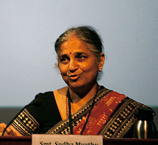
Life and Career
Sudha Murty was born in 1950 in Shiggaon, north Karnataka. She did her MTech in computer science, and is now the chairperson of the Infosys Foundation. A prolific writer in English and Kannada, she has written novels, technical books, travelogues, collections of short stories and non-fiction pieces, and six bestselling books for children. Her books have been translated into all the major Indian languages.

Sudha Murthy was born into a Madhwa family on 19 August 1950 in Shiggaon in Karnataka, India, the daughter of surgeon Dr. R. H. Kulkarni and his wife Vimala Kulkarni. She Was raised by her parents and maternal grandparents. These childhood experiences form the historical basis for her first notable work entitled How I Taught my Grandmother to Read & Other Stories. Murthy completed a B.E. in Electrical and Electronics Engineering from the B.V.B. College of Engineering & Technology (now known as KLE Technological University), standing first in her class and receiving a gold medal from the Chief Minister of Karnataka. Murthy completed M.E. in Computer Science from the Indian Institute of Science, standing first in her class and receiving a gold medal from the Indian Institute of Engineers.
Awards & Achievements
- Awarded Padmashri by Govt. of India in 2006
- IIT Kanpur awarded her Honorary Degree (Honoris Causa) of Doctor of Science (2019)
- Gold Medal from the Indian Institute of Engineers, India for having secured the 1st Rank in M.Tech. of all the branches of Engineering
- Gold Medal from the Chief Minister of Karnataka Sri Devaraj Urs, for securing the highest marks in B.E. of all the Universities of Engineering in Karnataka.

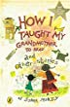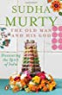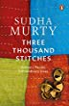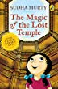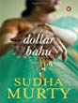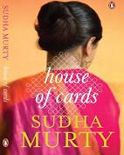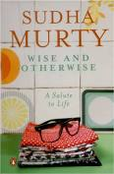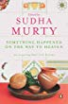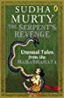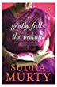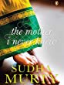

Links: -
- https://en.wikipedia.org/wiki/Sudha_Murty
- https://penguin.co.in/author/sudha-murty/

S. No | Book Cover Page | Details of the books
Title: How I taught my grandmother to read and other stories
Author: Murty, Sudha.,
Publisher: New Delhi:: Puffin Books,, 2004
Call No.: 823 MUR
Acc. No.: 004998, 004999, 008381, 008382, 008383, 008384
 | 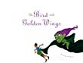 | Title: Bird with golden wings: stories of wit and magic  Author: Murty, Sudha.,  Publisher: New Delhi:: Puffin Books,, 2009  Call No.: 823.92 MUR  Acc. No.: 012232
Title: Old man and his God : discovering the spirit of India
Author: Murty, Sudha,
Publisher: New Delhi: Penguin Books, 2006
Call No.: 823 MUR
Acc. No.: 012235
Title: Three thousand stitches: ordinary people, extraordinary lives
Author: Murty, Sudha
Publisher: Gurgaon:: Penguin Random House India,, 2017
Call No.: 920 MUR
Acc. No.: 025504
Title: Magic drum and other favourite stories
Author: Murty, Sudha
Publisher: Haryana:: Puffin Books,, 2006
Call No.: 398.20954 MUR
Acc. No.: 025926
Title: Dollar bahu
Author: Murty, Sudha
Publisher: Haryana:: Penguin Books,, 2007
Call No.: 891.43 MUR
Acc. No.: 025927
Title: House of cards
Author: Murty, Sudha
Publisher: Haryana:: Penguin Books,, 2013
Call No.: 823.914 MUR
Acc. No.: 025928
Title: Wise and otherwise: a salute to life
Author: Murty, Sudha
Publisher: Haryana:: Penguin Books,, 2006
Call No.: 823 MUR
Acc. No.: 025929
Title: Something happened on the way to heaven: 20 Inspiring real-life stories
Author: Murty, Sudha, Ed.
Publisher: Haryana:: Penguin Books,, 2014
Call No.: 128 MUR
Acc. No.: 025930
Title: Serpent’s revenge: unusual tales from the Mahabharata
Author: Murty, Sudha
Publisher: Haryana:: Puffin Books,, 2016
Call No.: 823.91 MUR
Acc. No.: 025931
 | 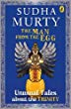 | Title: Man from the egg: unusual tales about the trinity  Author: Murty, Sudha  Publisher: Haryana:: Puffin Books,, 2017  Call No.: 294.513 MUR  Acc. No.: 025932
Title: Gently falls the Bakula
Author: Murty, Sudha
Publisher: Haryana:: Penguin Books,, 2008
Call No.: 894.814 MUR
Acc. No.: 025933
 | 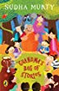 | Title: Grandmas bag of stories  Author: Murty, Sudha,  Publisher: New Delhi:: Puffin .,, 2012  Call No.: 823.0108 MUR  Acc. No.: CC0397
 | 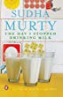 | Title: Day I stopped drinking milk: life stories from here and there  Author: Murty, Sudha  Publisher: New Delhi:: Penguin Books,, 2012  Call No.: 920.054 MUR  Acc. No.: CC0890
Title: Magic of the lost temple
Author: Murty, Sudha
Publisher: New Delhi:: Puffin Books,, 2015
Call No.: 823.914 MUR
Acc. No.: CC0907
 | 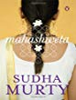 | Title: Mahashweta  Author: Murty, Sudha  Publisher: New delhi:: Puffin Books, 2005  Call No.: 823.914 MUR  Acc. No.: CC0908
Title: Mother I never knew: two novellas
Author: Murty, Sudha
Publisher: New Delhi:: Puffin Books, 2014
Call No.: 823.92 MUR
Acc. No.: CC0909

