Author of the Week: Eliyahu Moshe Goldratt
Eliyahu Moshe Goldratt (March 31, 1947 – June 11, 2011) was an Israeli business management guru Goldratt was born in British Mandatory Palestine one year prior to Israel's modern statehood. He obtained BSc degree from Tel Aviv University, and MSc and PhD degrees from Bar-Ilan University in Ramat Gan, Israel. Goldratt died on June 11, 2011. Time Magazine listed his book “The Goal” as one of “The 25 Most Influential Business Management Books.

Links:
- https://www.tocinstitute.org/eliyahu-goldratt.html
- https://en.wikipedia.org/wiki/Eliyahu_M._Goldratt

Sr.No. |  | Book Image | Bibliography Details
1. |  | 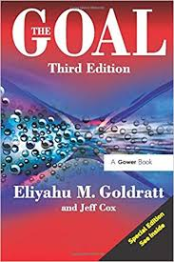 | Title: Goal : a process of ongoing improvement  Author: Goldratt, Eliyahu M  Publisher: Chennai: Productivity and Quality Publishing, 1984  Call No.: 823.914 GOL  Acc. No.: 004638
2. |  | 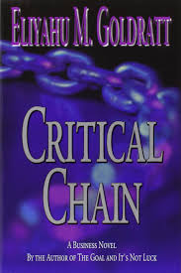 | Title: Critical chain  Author: Goldratt, Eliyahu M.  Publisher: Chennai: Productivity and Quality Publishing, 2010  Call No.: 658.404 GOL  Acc. No.: 009282
3. |  | 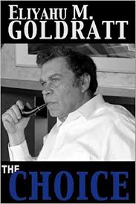 | Title: Choice  Author: Goldratt, Eliyahu M.  Publisher: Chennai: Productivity and Quality Publishing, 2009  Call No.: 823.914 GOL  Acc. No.: 009283
4. |  | 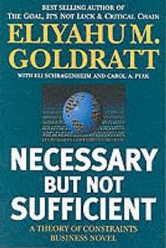 | Title: Necessary but not sufficient : a theory of constraints business novel  Author: Goldratt, Eliyahu M.  Publisher: Chennai: Productivity and Quality Publishing, 2008  Call No.: 658 GOL  Acc. No.: 009284
5. |  | 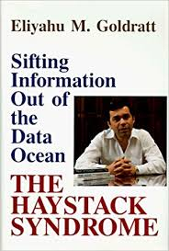 | Title: The haystack syndrome : sifting information out of the data ocean  Author: Goldratt, Eliyahu M.  Publisher: New York: North River Press, 1990  Call No.: 658.4038 GOL  Acc. No.: 009432
6. |  | 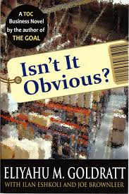 | Title: Isn’t it obvious?  Author: Goldratt, Eliyahu M.  Publisher: MA: North River Press, 2009  Call No.: 650.1 GOL  Acc. No.: 009433
7. |  | 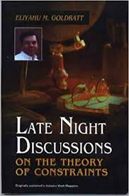 | Title: Late night discussions on the theory of constraints  Author: Goldratt, Eliyahu M.  Publisher: Great Barrington, MA: North River Press, 1992  Call No.: 658.5 GOL  Acc. No.: 009577
8. |  | 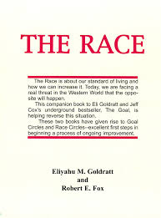 | Title: The race  Author: Goldratt, Eliyahu M.  Publisher: Croton-on-Hudson: North River Press, 1986  Call No.: 658.787 GOL  Acc. No.: 009578
9. |  | 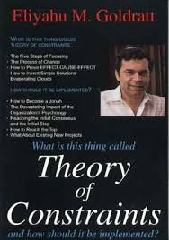 | Title: What is this thing called theory of constraints and how should it be implemented?  Author: Goldratt, Eliyahu M.  Publisher: Great Barrington: North River Press, 1990  Call No.: 658.1552 GOL  Acc. No.: 009579
10. |  | 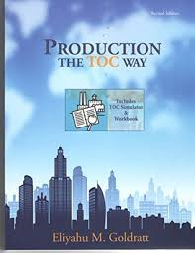 | Title: Production the TOC Way : tutor guide Eliyahu M. Goldratt  Author: Goldratt, Eliyahu M.  Publisher: Madras: North River Press, 1986  Call No.: 658 GOL  Acc. No.: 011177 & C00582

Date: 25.01.2020

