Author of the Week: Gabriel Garcia Marquez
Gabriel Garcia Marquez was born in 1927 in the small town of Aracataca, situated in a tropical region of northern Colombia, between the mountains and the Caribbean Sea. He grew up with his maternal grandparent – his grandfather was a pensioned colonel from the civil war at the beginning of the century. He went to a Jesuit college and began to read law, but his studies were soon broken off for his work as a journalist. In 1954 he was sent to Rome on an assignment for his newspaper, and since then he has mostly lived abroad – in Paris, New York, Barcelona and Mexico – in a more or less compulsory exile. Besides his large output of fiction, he has written screenplays and has continued to work as a journalist.
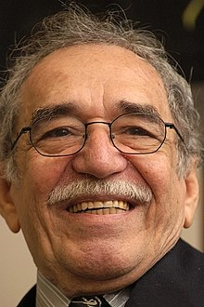
Life and Career
“In his long literary career, he penned over 25 books, transporting readers into a world of magical realism where they find themselves in the lush, humid tropics – moldering into solitude or being slowly consumed by the throes of passion,” Google says in its blog.
Garcia Marquez was known for his capacity to create vast, minutely woven plots and brief, tightly knit narratives in the fashion of his two North American models, William Faulkner and Ernest Hemingway. The easy flow of even the most intricate of his stories has been compared to that of Miguel de Cervantes, as have his irony and overall humour.
Garcia Marquez’s novelistic world is mostly that of provincial Colombia, where medieval and modern practices and beliefs clash both comically and tragically. With Jorge Luis Borges, García Márquez is the best-known Latin American writer in history. In addition to his masterly approach to the novel, he was a superb crafter of short stories and an accomplished journalist.
Awards
- The Nobel Prize in Literature 1982

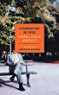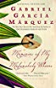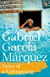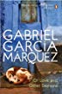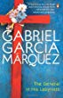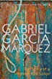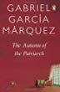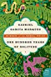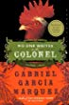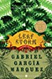

Links: -
- https://www.nobelprize.org/prizes/literature/1982/marquez/biographical/
- https://openlibrary.org/authors/OL4586796A/Gabriel_Garcia_Ma%CC%81rquez
- https://en.wikipedia.org/wiki/Gabriel_Garc%C3%ADa_M%C3%A1rquez#Legacy

Books by Gabriel Garcia Marquez

Title: One Hundred Years of Solitude
Author: Marquez, Gabriel Garcia .,
Publisher: New York:: Harper Perennial Modern Classics,, 1967
Call No.: 863 MAR
Acc. No.: 002097 & 007019
Title: Love in the time of cholera
Author: Marquez, Gabriel Garcia,
Publisher: New Delhi: Penguin Books, 2007
Call No.: 863.64 MAR
Acc. No.: 018085
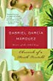 | Title: Chronicle of a death foretold  Author: Marquez, Gabriel Garcia,  Publisher: New Delhi: Penguin Books, 2014  Call No.: 863 MAR  Acc. No.: 018306
Title: Memories of my melancholy whores
Author: Marquez, Gabriel Garcia
Publisher: New York:: Penguin Random House,, 2005
Call No.: 863.64 MAR
Acc. No.: 025998
Title: No one writes to the colonel
Author: Marquez, Gabriel Garcia
Publisher: London:: HarperCollins Publishers,, 2005
Call No.: 863.64 MAR
Acc. No.: 025999
Title: Of love and other demons
Author: Marquez, Gabriel Garcia
Publisher: Haryana:: Penguin Random House,, 1995
Call No.: 863.64 MAR
Acc. No.: 026001
Title: Autumn of the patriarch
Author: Marquez, Gabriel Garcia
Publisher: Haryana:: Penguin Random House,, 1995
Call No.: 863.64 MAR
Acc. No.: 026003
Title: General in his labyrinth
Author: Marquez, Gabriel Garcia
Publisher: Haryana:: Penguin Random House,, 1991
Call No.: 863.64 MAR
Acc. No.: 026004
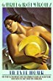 | Title: In evil hour  Author: Marquez, Gabriel Garcia  Publisher: London:: HarperCollins,, 1979  Call No.: 863.64 MAR  Acc. No.: 026122
Title: Leaf storm and other stories
Author: Marquez, Gabriel Garcia
Publisher: London:: HarperCollins,, 1972
Call No.: 863.64 MAR
Acc. No.: 026124
Title: Story of a shipwrecked sailor
Author: Marquez, Gabriel Garcia
Publisher: London:: Penguin Books,, 1986
Call No.: 863 MAR
Acc. No.: 026133
Title: News of a kidnapping
Author: Marquez, Gabriel Garcia
Publisher: London:: Penguin Random House,, 1996
Call No.: 364.15409861 MAR
Acc. No.: 026207
Title: Clandestine in Chile: the adventures of Miguel Littin
Author: Marquez, Gabriel Garcia
Publisher: New York: New York Book Review, 1986
Call No.: 983.0646 MAR
Acc. No.: 026377

Compiled by
Library
IIT Gandhinagar

