साप्ताहिक लेखक - शिवानी
Author of the Week: Shivani
Gaura Pant 'Shivani' was born on 17 October 1924, the Vijaya Dasami day in Rajkot, Gujarat, where her father, Ashwini Kumar Pande was a teacher with princely state of Rajkot. He was a Kumaoni Brahmin. Her mother was a Sanskrit scholar, and the first student of Lucknow Mahila Vidyalaya. Later her father became the Diwan with the Nawab of Rampur and the member of Viceroy's Bar Council, thereafter the family moved to the princely state of Orchha, where her father held an important position. Thus Shivani's childhood had influences of these varied places, and an insight into women of privilege, which reflected in much of her work. At Lucknow, she became the first student of the local, 'Lucknow Mahila Vidyalaya'.
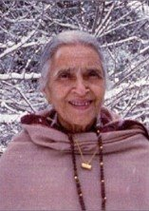
Life and Career
She garnered a massive following in the pre-television 1960s and 1970s, as her literary works (like her most famous novel, 'Krishnakali'), were serialised in Hindi magazines like Dharmayug and Saptahik Hindustan, leading to her cult status as a Hindi magazine novelist.[3] Through her writings, she also made the culture of Kumaon, somewhat known to Hindi-speaking Indians across the country. Her novel 'Kariye Chima' was made into a film, while her other novels including 'Surangma', 'Rativilaap', 'Mera Beta', and 'Teesra Beta' have been turned into Television serials.

In 1951, her short story, 'Main Murga Hun' (I am a Chicken) was published in Dharmayug, and she became Shivani, from Gaura Pant. Her first novel, Lal Haveli, established her reputation in the early sixties, and in the next ten years she produced several major works which were serialised in the Hindi magazine, Dharmayug. Proficient in many other languages including Sanskrit, Gujarati, Bengali, Urdu, and English, Shivani received the Padma Shri for her contribution to Hindi literature in 1982. She was a prolific writer; her oeuvre consists of over 40 novels, many short stories and hundreds of articles and essays. Her most famous works include Chaudah Phere, Krishnakali, Lal Haveli, Smashan Champa, Bharavi, Rati Vilap, Vishkanya, Apradhini (a collection of interviews with women lifers); travelogues: 'Yatriki', based on her London travels and 'Chareivati', based on her travels to Russia.
Awards & Achievements
- Padma Shri (1982)

Links: -
- https://en.wikipedia.org/wiki/Shivani
- https://www.rajkamalprakashan.com/index.php/radha/jmproducts/filter/index/?author=1040
- https://www.goodreads.com/author/show/3353307.Shivani

Books by Shivani
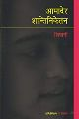 | Title: Aamader shantiniketan  Author: Shivani,  Publisher: New Delhi: Rajkamal Prakashan, 2007  Call No.: 891.433 SHI  Acc. No.: 017695
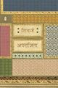 | Title: Aparajita  Author: Shivani,  Publisher: New Delhi: Radhakrishana Prakashan, 2007  Call No.: 891.433 SHI  Acc. No.: 017707
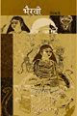 | Title: Bhairavee  Author: Shivani.,  Publisher: New Delhi: Radhakrishana Prakashan, 2009  Call No.: 891.433 SHI  Acc. No.: 017714
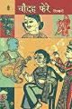 | Title: Chaudah phere  Author: Shivani.,  Publisher: New Delhi: Radhakrishana Prakashan, 2014  Call No.: 891.433 SHI  Acc. No.: 017721
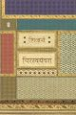 | Title: Chirswayamvara  Author: Shivani.,  Publisher: New Delhi: Rajkamal Prakashan, 2011  Call No.: 891.433 SHI  Acc. No.: 017723
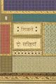 | Title: Do sakhiyan  Author: Shivani.,  Publisher: New Dilhi: Radhakrishana Prakashan, 2007  Call No.: 891.433 SHI  Acc. No.: 017726
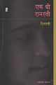 | Title: Ek thi Ramrati  Author: Shivani,  Publisher: New Dilhi: Radhakrishana Prakashan, 2007  Call No.: 891.43808 SHI  Acc. No.: 017729
Title: Jalak
Author: Shivani.,
Publisher: New Delhi: Radhakrishana Prakashan, 2009
Call No.: 891.433 SHI
Acc. No.: 017736
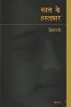 | Title: Kal ke hastakshar  Author: Shivani.,  Publisher: New Delhi: Rajkamal Prakashan, 2007  Call No.: 891.433 SHI  Acc. No.: 017740
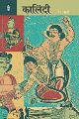 | Title: Kalindi  Author: Shivani,  Publisher: New Delhi: Radhakrishana Prakashan, 2009  Call No.: 891.433 SHI  Acc. No.: 017744
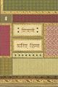 | Title: Kariye chhima  Author: Shivani,  Publisher: New Delhi: Radhakrishana Prakashan, 2007  Call No.: 891.43301 SHI  Acc. No.: 017747
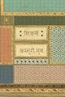 | Title: Kasturi mrig  Author: Shivani.,  Publisher: New Delhi: Radhakrishana Prakashan, 2007  Call No.: 891.43301 SHI  Acc. No.: 017748
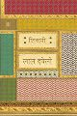 | Title: Lal haveli  Author: Shivani,  Publisher: New Delhi: Radhakrishana Prakashan, 2007  Call No.: 891.433 SHI  Acc. No.: 017752
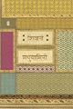 | Title: Madhuyamini  Author: Shivani,  Publisher: New Delhi: Radhakrishana Prakashan, 2008  Call No.: 891.433 SHI  Acc. No.: 017753
Title: Maran sagar pare
Author: Shivani,
Publisher: New Delhi: Radhakrishana Prakashan, 2007
Call No.: 891.433 SHI
Acc. No.: 017757
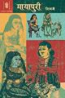 | Title: Mayapuri  Author: Shivani,  Publisher: New Delhi: Radhakrishana Prakashan, 2009  Call No.: 891.433 SHI  Acc. No.: 017758
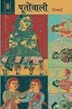 | Title: Pootonwali  Author: Shivani,  Publisher: New Delhi: Radhakrishana Prakashan, 2009  Call No.: 891.433 SHI  Acc. No.: 017768
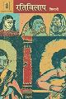 | Title: Rativilaap  Author: ,Shivani  Publisher: New Delhi: Radhakrishana Prakashan, 2009  Call No.: 891.433 SHI  Acc. No.: 017774
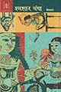 | Title: Shamshan champa  Author: Shivani,  Publisher: New Delhi:: Radhakrishana Prakashan,, 2009  Call No.: 891.433 SHI  Acc. No.: 017783
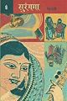 | Title: Surangama  Author: Shivani,  Publisher: New Delhi: Radhakrishana Prakashan, 2009  Call No.: 891.433 SHI  Acc. No.: 017795
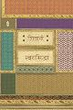 | Title: Swayamsiddha  Author: Shivani,  Publisher: New Delhi: Radhakrishana Prakashan, 2011  Call No.: 891.43301 SHI  Acc. No.: 017796
Title: Vatayan
Author: Shivani,
Publisher: New Delhi: Radhakrishana Prakashan, 2011
Call No.: 891.43808 SHI
Acc. No.: 017801
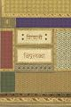 | Title: Vipralabdha  Author: Shivani,  Publisher: New Delhi: Radhakrishana Prakashan, 2007  Call No.: 891.43301 SHI  Acc. No.: 017803
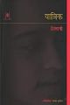 | Title: Yatrik  Author: Shivani.,  Publisher: New Delhi: Radhakrishana Prakashan, 2007  Call No.: 891.43808 SHI  Acc. No.: 017804
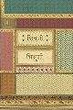 | Title: Bhiksuni  Author: Shivani,  Publisher: New Delhi: Radhakrishana Prakashan, 2009  Call No.: 891.43371 SHI  Acc. No.: 019496

Compiled by
Library
IIT Gandhinagar

