Author of the Week
Toni Morrison
Toni Morrison is a Nobel Prize and Pulitzer Prize-winning American novelist. Among her best known novels are 'The Bluest Eye,' 'Song of Solomon,' 'Beloved' and 'A Mercy.'
In 1996, the National Endowment for the Humanities selected her for the Jefferson Lecture, the U.S. federal government's highest honor for achievement in the humanities. She was honored with the 1996 National Book Foundation's Medal of Distinguished Contribution to American Letters. Morrison wrote the libretto for a new opera, Margaret Garner, first performed in 2005. On May 29, 2012, President Barack Obama presented Morrison with the Presidential Medal of Freedom.
“If there's a book that you want to read, but it hasn't been written yet, then you must write it.” Toni Morrison
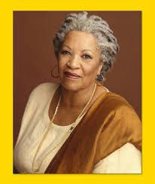

Life and career

Toni Morrison was born into a working-class family in Lorain, Ohio in the United States. She read a lot as a child and her father's stories, taken from the African-American tradition, later became an element in her own writing. She has studied and taught English at several universities, including Howard University in Washington D.C. From 1964 she worked as a publishing house editor, and since her debut as an author in 1970, she has also held positions at several universities, including Princeton. Toni Morrison has two children from her marriage to Harold Morrison.
Toni Morrison's works revolve around African-Americans; both their history and their situation in our own time. Her works often depict difficult circumstances and the dark side of humanity, but still convey integrity and redemption. The way she reveals the stories of individual lives conveys insight into, understanding of, and empathy for her characters. Toni Morrison's unique narrative technique has developed with each new work. Among her works are her debut novel, The Bluest Eye, Song of Solomon, and Beloved etc.

Important Links
https://www.nobelprize.org/nobel_prizes/literature/laureates/1993/morrison-bio.html
http://www.bbc.com/culture/story/20140606-toni-morrison-childhood-memories
https://www.youtube.com/watch?v=DUr_XoMCPFA
https://www.youtube.com/watch?v=EjdyX2wnwdY

Books by and on Toni Morrison
 | Title: Beloved  Author: Toni Morrison  Publisher : Vintage (London)  ISBN: 9780099273936  Call No. : 813.54 MOR  Accession No. : 008507 | 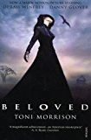

2. | Title: Bluest eye  Author: Toni Morrison  Publisher : Vintage (London)  ISBN: 9780099759911  Call No. : 813.54 TON  Accession No. : 007567 to 007575 | 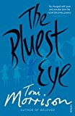

3. | Title: Jazz  Author: Toni Morrison  Publisher : Vintage (London)  ISBN: 9780099750918  Call No. : 813.54 MOR  Accession No. : 008505 | 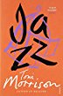

4. | Title: Love  Author: Toni Morrison  Publisher : Vintage (London)  ISBN: 9780099455493  Call No. : 813.54 MOR  Accession No. : 008506 | 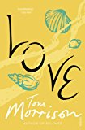

5. | Title: Mercy  Author: Toni Morrison  Publisher : Vintage (London)  ISBN: 9780099535331  Call No. : 813.54 MOR  Accession No. : 008502 | 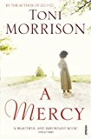

6. | Title: Paradise  Author: Toni Morrison  Publisher : Vintage (London)  ISBN: 9780099768210  Call No. : 813.54 MOR  Accession No. : 008503 | 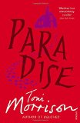

7. | Title: Song of Solomon  Author: Toni Morrison  Publisher : Vintage (London  ISBN: 9780099768418  Call No. : 813.54 MOR  Accession No. : 008501 | 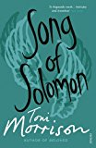

8. | Title: Sula  Author: Toni Morrison  Publisher : Vintage (London  ISBN: 9780099760016  Call No. : 813.54 MOR  Accession No. : 008508 | 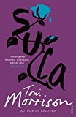

9. | Title: Tar baby  Author: Toni Morrison  Publisher : Vintage (London  ISBN: 9780099760214  Call No. : 813.54 MOR  Accession No. : 008504 | 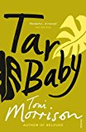

Compiled by Library
Date 4.10.2017

