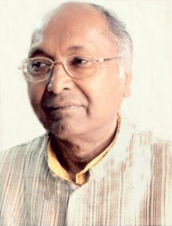
Author of the Week: Giriraj Kishore
Giriraj Kishore was born in Muzzafarnagar in 1937. His father was a zamindar, but because of his socialist principles and lack of interest in zamindari system Giriraj left home at a young age and became a Gandhian. He completed his Masters in Social Work from The Institute of Social Sciences, Agra. He completed a emeritus fellowship by the University Grants Commission, Government of India in 1998-1999 and a fellowship at Indian Institute of Advanced Study, Simla from 1999 to 2001
About and Awards
Later he worked at different posts as an officer in the government, including as registrar of Kanpur University (Chhatrapati Shahu Ji Maharaj University) and the Indian Institute of Technology Kanpur in a career spanning more than 30 years. He was formerly a member of the Sahitya Akademi working committee, and the Railway Board of GOI.

He is married to Mrs. Meera Kishore and has 2 daughters and a son. Both his daughters are married. At present he resides in Kanpur and is writing few novels. He also writes articles regularly in newspapers and is the editor of a Hindi magazine Aakar.

Awards
- Padma Shri (2007)
- Sahitya Akademi Award (1992)
- Vyas Samman (2000)

Works
- Story collections
Paperweight, Meri rajnaitik khaniyan, Neem ke phool, etc.
- Novels
Log, Chidiyaghar, Do, Parishisht, Dhai Ghar, Phela Girmitiya, etc.
- Drama
Narmedh, Kaath ki top, Praja hi Rhene do, etc.

To know more please visit the following Links
- https://en.wikipedia.org/wiki/Giriraj_Kishore_(writer)
- https://www.revolvy.com/page/Giriraj-Kishore-%28writer%29

Books by Giriraj Kishore
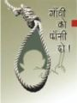 | Title: Gandhi ko phansi do  Author: Kishore, Giriraj  Publisher: Delhi: Rajpal & Sons, 2009  Call No.: 891.432 KIS  Acc. No.: 012407
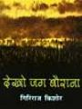 | Title: Dekho jag baurana  Author: Kishore, Giriraj  Publisher: Delhi: Rajpal & Sons, 2010  Call No.: 891.433 KIS  Acc. No.: 012398
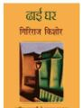 | Title: Dhai Ghar  Author: Kishore, Giriraj  Publisher: Delhi: Rajpal & Sons, 2011  Call No.: 891.433 KIS  Acc. No.: 012399
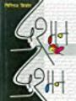 | Title: Dushman aur dushman  Author: Kishore, Giriraj  Publisher: Delhi: Rajpal & Sons, 2009  Call No.: 891.433 KIS  Acc. No.: 012402
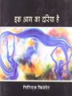 | Title: Ek aag ka dariya hai  Author: Kishore, Giriraj  Publisher: New Delhi: Bhartiya Jnanpith, 2010  Call No.: 891.433 KIS  Acc. No.: 012416
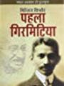 | Title: Pehla girmitiya  Author: Kishore, Giriraj  Publisher: Delhi: Rajpal & Sons, 2011  Call No.: 891.433 KIS  Acc. No.: 012447
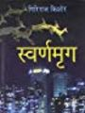 | Title: Swaranmrig  Author: Kishore, Giriraj  Publisher: Delhi: Rajpal & Sons, 2012  Call No.: 891.433 KIS  Acc. No.: 012460
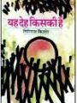 | Title: Yah deh kiski hai?  Author: Kishore, Giriraj  Publisher: New Delhi: Bhartiya Jananpith, 2004  Call No.: 891.433 KIS  Acc. No.: 012468
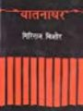 | Title: Yatnadhar  Author: Kishore, Giriraj  Publisher: Delhi: Rajpal & Sons, 2011  Call No.: 891.433 KIS  Acc. No.: 012469
Title: Jugalbandi
Author: Kishore, Giriraj
Publisher: New Delhi: Rajkamal Prakashan, 2003
Call No.: 891.433 KIS
Acc. No.: 017739
Title: Parishisht
Author: Kishore, Giriraj
Publisher: New Delhi: Rajkamal Prakashan, 2011
Call No.: 891.433 KIS
Acc. No.: 017766

Compiled by Library
16th August, 2019

