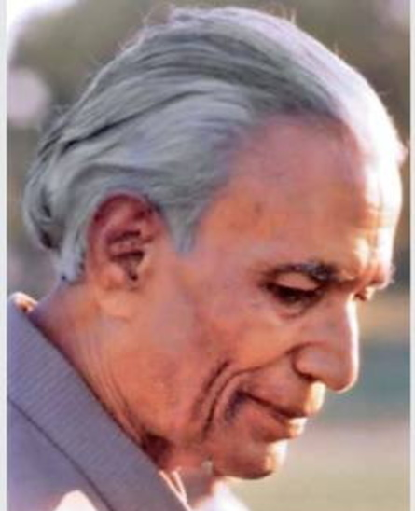
Dharamvir Bharati was born on 25 December 1926 in a Kayastha Family of Allahabad to Chiranji Lal and Chanda Devi. The family underwent considerable financial hardships after his father died early. He had a sister, Dr. Veerbala.He did his MA in Hindi from Allahabad University in 1946 and won the "Chintamani Ghosh Award" for securing highest marks in Hindi. Dharamvir Bharati was the sub-editor for magazines Abhyudaya and Sangam during this period. He completed his PhD in 1954 under Dr. Dhirendra Verma on the topic of "Siddha Sahitya" and was appointed lecturer in Hindi at Allahabad University. The 1950s were the most creative period in Bharati's life: He wrote many novels, dramas, poems, essays, and critical works during this phase.
Author of the Week: Dharamvir Bharati

Awards & Notable Works

Awards
- Padma Shri by the Government of India, 1972
- Rajendra Prasad Shikhar Samman
- Bharat Bharati Samman
- Maharashtra Gaurav, 1994
- Kaudiya Nyas
- Vyasa Samman
- 1984, Valley Turmeric Best journalism awards
- 1988, best playwright Maharana Mewar Foundation Award
- 1989, the Sangeet Natak Akademi, Delhi
Notable Works
- Gunaho Ka Devta
- Suraj ka Satwan Ghoda
- Giyara sapno ka desh
- Prarambh va Samapan
- Band gali Ka Aakhkri Makaan
- Saas ki Kalam se
- Samasta Kahaniya ek Saath
- Swarg aur Prathvhi
- Chand aur Tute hue Log
- Thele par Himalayas
- Pashyanti stories: Ankahi

For more Information
https://pustak.org/index.php/books/authorbooks/Dharamvir%20Bharti
https://en.wikipedia.org/wiki/Dharamvir_Bharati
Books by Dharmvir Bharati

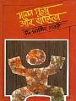 | Title: Manav Mulya aur sahtiya  Author: Bharati, Dharmvir  Publisher: New Delhi: Bharatiya Jnanpith, 2006  Call No.: 891.43 BHA  Acc. No.: 019538
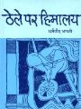 | Title: Thele Par Himalaya  Author: Bharati, Dharmvir  Publisher: New Delhi: Bharatiya Jnanpith, 2006  Call No.: 891.43 BHA  Acc. No.: 019565
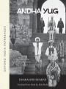 | Title: Andha yug :  Author: Bharati, Dharmvir  Publisher: Delhi: Oxford University Press, 2005  Call No.: 891.43271 BHA  Acc. No.: 009854
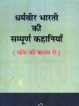 | Title: Dharmvir bharti ki sampurna kahaniyan: sans ki kalam se  Author: Bharati, Dharmvir  Publisher: New Delhi: Bhartiya Gyanpith Prakashan, 2011  Call No.: 891.4337 BHA  Acc. No.: 018232
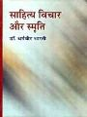 | Title: Sahitya vichar aur samriti  Author: Bharati, Dharmvir  Publisher: New Delhi: Bhartiya Gyanpith Prakashan, 2003  Call No.: 891.4337 BHA  Acc. No.: 018243
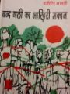 | Title: Band Gali Ka Akhiri Makan  Author: Bharati, Dharmvir  Publisher: New Delhi: Bharatiya Jnanpith, 1983  Call No.: 891.4337 BHA  Acc. No.: 019492
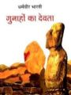 | Title: Gunaho ka devta  Author: Bharati, Dharmvir  Publisher: New Delhi: Bharatiya Jnanpith, 2011  Call No.: 891.4337 BHA  Acc. No.: 019514
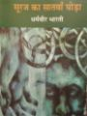 | Title: Suraj ka saantwa ghoda  Author: Bharati, Dharmvir  Publisher: New Delhi: Bharatiya Jnanpith, 2011  Call No.: 891.4337 BHA  Acc. No.: 019563
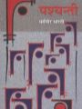 | Title: Pashyanti  Author: Bharati, Dharmvir  Publisher: New Delhi: Bharatiya Jnanpith, 2003  Call No.: 891.434 BHA  Acc. No.: 019548

Compiled by Library
21st June 2019

