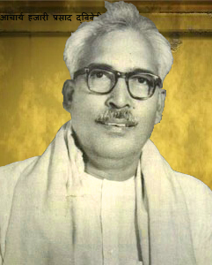
Hazari Prasad Dwivedi
Hazari Prasad Dwivedi (19 August 1907 – 19 May 1979) was a Hindi novelist, literary historian, essayist, critic and scholar. He penned numerous novels, collections of essays, historical research on medieval religious movements of India especially Kabir and Natha Sampradaya, and historical outlines of Hindi literature. Besides Hindi, he was master of many languages including Sanskrit, Bengali, Punjabi, Gujarati as well as Pali, Prakrit, and Apabhramsa.
Steeped in traditional knowledge of Sanskrit, Pali and Prakrit, and modern Indian languages, Dwivedi was destined to be the great bridge maker between the past and the present. As a student of Sanskrit, steeped in the Sastras, he gave a new evaluation to Sahitya-sastra and he can rightly be considered as a great commentator on the textual tradition of the Indian literature.
He was awarded the Padma Bhushan in 1957 for his contribution to Hindi literature, and the 1973 Sahitya Akademi Award for his collection of essays, 'Alok Parva'.

Author of the Week

आचार्य हजारी प्रसाद द्विवेदी
(सन् 1907-1979 ई.)
Notable Awards: 1973: Sahitya Akademi Award
1957: Padma Bhushan

Works:
- Sahitya ki Bhumika
- Hindi Sahitya ka Adikala
- Kabir
- Madhyakalin Dharma Sadhana
- Natha Sampradaya
- Banbhatta Ki Atmakatha (1946)
- Anamdas Ka Potha
- Punarnava
- Charu-chandra-Lekha
- Nakhoon Kyon Barhte Hain (Why do the nails grow)
- Ashok ke phool
- Kutaj
He also translated many works from English and other languages to Hindi. These include:
- Prabandha-Chintamani (from Prakrit)
- Puratan Prabandha Sangraha
- Vishva Parichay
- Lal Kaner
- Mouthi mar thi hoa mara
For more details:
https://hindijivanparichya.blogspot.com/2017/09/blog-post_31.html
https://en.wikipedia.org/wiki/Hazari_Prasad_Dwivedi

Awards and Works
Books by Hazari Prasad Dwivedi

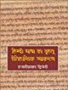 | Title: Hindi bhasha ka vrihat eitihasik vyakaran  Author: Dwivedi, Hazari Prasad  Publisher: New Delhi: Rajkamal Prakashan, 2011  Call No.: 491.435 DWI  Acc. No.: 017732
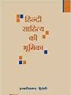 | Title: Hindi sahitya ki bhoomika: a literary criticism  Author: Dwivedi, Hazari Prasad  Publisher: New Delhi: Rajkamal Prakashan, 2012  Call No.: 891.4308 DWI  Acc. No.: 017734
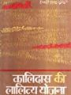 | Title: Kalidas ki lalitya yojana  Author: Dwivedi, Hazari Prasad  Publisher: New Delhi: Rajkamal Prakashan, 1998  Call No.: 891.4308 DWI  Acc. No.: 017743
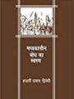 | Title: Madhyakalin bodh ka swroop  Author: Dwivedi, Hazari Prasad  Publisher: New Delhi: Rajkamal Prakashan, 2003  Call No.: 891.4308 DWI  Acc. No.: 017754
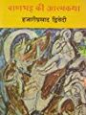 | Title: Banbhatt ki aatmakatha  Author: Dwivedi, Hazari Prasad  Publisher: New Delhi: Rajkamal Prakashan, 2010  Call No.: 891.4309 DWI  Acc. No.: 017711
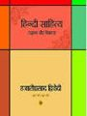 | Title: Hindi sahitya ka aadikal  Author: Dwivedi, Hazari Prasad  Publisher: New Delhi: Vani Prakashan, 2008  Call No.: 891.4309 DWI  Acc. No.: 017733
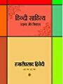 | Title: Hindi sahitya udbhav aur vikas  Author: Dwivedi, Hazari Prasad  Publisher: New Delhi: Rajkamal Prakashan, 2011  Call No.: 891.4309 DWI  Acc. No.: 017735
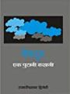 | Title: Meghdoot : ek purani kahani  Author: Dwivedi, Hazari Prasad  Publisher: New Delhi: Rajkamal Prakashan, 2009  Call No.: 891.4309 DWI  Acc. No.: 017759
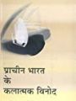 | Title: Prachin bharat ke klatmak vinod  Author: Dwivedi, Hazari Prasad  Publisher: New Delhi: Rajkamal Prakashan, 2002  Call No.: 891.4309 DWI  Acc. No.: 017770
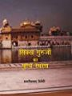 | Title: Sikkh guruon ka punysmaran  Author: Dwivedi, Hazari Prasad  Publisher: New Delhi: Rajkamal Prakashan, 2007  Call No.: 891.4309 DWI  Acc. No.: 017790
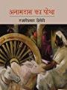 | Title: Anamdas ka potha  Author: Dwivedi, Hazari Prasad  Publisher: New Delhi: Rajkamal Prakashan, 2010  Call No.: 891.433 DWI  Acc. No.: 017703
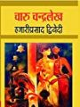 | Title: Charu Chandralekh  Author: Dwivedi, Hazari Prasad  Publisher: New Delhi: Rajkamal Prakashan, 2006  Call No.: 891.433 DWI  Acc. No.: 017719
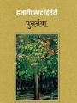 | Title: Punarnva  Author: Dwivedi, Hazari Prasad  Publisher: New Delhi: Rajkamal Prakashan, 2010  Call No.: 891.433 DWI  Acc. No.: 017772
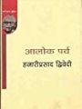 | Title: Aalok parv  Author: Dwivedi, Hazari Prasad  Publisher: New Delhi: Rajkamal Prakashan, 1998  Call No.: 891.434 DWI  Acc. No.: 017697
Title: Kalplata
Author: Dwivedi, Hazari Prasad
Publisher: New Delhi: Rajkamal Prakashan, 2007
Call No.: 891.434 DWI
Acc. No.: 017746

Compiled by library
06th June 2019

