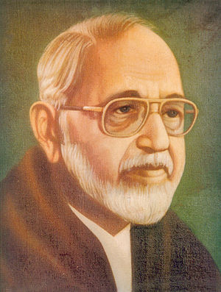
Sachchidananda Hirananda Vatsyayan, popularly known by his
Author of the Week
pen-name, Agyeya (Unknowable), was a pioneering writer of modern Hindi poetry, fiction, criticism and journalism. He was one of the most prominent exponents of the Nayi Kavita (New Poetry) and Prayogavaad (Experimentalism) movements in modern Hindi literature. He also edited the Saptaks, a poetry series, and started the Hindi newsweekly Dinaman.
Agyeya also translated some of his own works, as well as works of some other Indian authors to English. He also translated some books of world literature into Hindi.
His career

Awards and honors
  - Sahitya Akademi Award in 1964 for Aangan Ke Par Dvar (Poetry).
  - Jnanpith Award in 1978, for 'Kitni Naavon mein kitni baar', and the anthology of poems.
  - Golden Wreath Award for poetry in 1983.

Major Works

• Kavita bhagot (1933)
• Chinta (1942)
• Ityalam (1946)
• Haree ghaas par pal bhar (1949)
• Baavara aheree (1954)
• Aangan ke paar dvaar (1961)
• Poorva (1965)
• Kaee baar bahut baar (1967)
• Kyonki main use jaanata hoon (1969)
• Saagar mudra (1970)
• Pahale main sannaata bunata hoon (1973)

Important Links:
- https://en.wikipedia.org/wiki/Sachchidananda_Vatsyayan

Books by Sachchidananda Vatsyayan ‘Agyeya’

Title: Taar saptak
Author: Agyeya
Publisher: New Delhi: Bharatiya Jnanpith, 2009
Call No.: 891.43081 AJN
Acc. No.: 017797
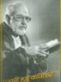 | Title: Chuni hui kavitaye  Author: Agyeya  Publisher: Delhi: Rajpal & Sons, 2010  Call No.: 891.431 AGN  Acc. No.: 012396
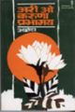 | Title: Ari O Aruna Prabhamaya  Author: Agyeya  Publisher: New Delhi: Bhartiya Gyanpith Prakashan, 2012  Call No.: 891.431 AGY  Acc. No.: 017710
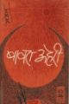 | Title: Bawara aheri  Author: Agyeya  Publisher: New Delhi: Bharatiya Jnanpith, 2011  Call No.: 891.431 AGY  Acc. No.: 017712
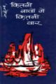 | Title: Kitni navon main kitni baar  Author: Agyeya  Publisher: New Delhi: Bhartiya Gyanpith Prakashan, 2012  Call No.: 891.431 AJN  Acc. No.: 017750
Title: Doosara saptak
Author: Agyeya
Publisher: New Delhi: Bharatiya Jnanpith, 2009
Call No.: 891.431 DOO
Acc. No.: 017727
Title: Tisara saptak
Author: Agyeya
Publisher: New Delhi: Bharatiya Jnanpith, 2009
Call No.: 891.431 TIS
Acc. No.: 017799
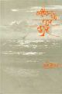 | Title: Angan ke par dwar: 1559-61 ki kavitayen  Author: Vatsyayan, Sachchidananda  Publisher: New Delhi: Bhartiya Gyanpith Prakashan, 2010  Call No.: 891.431 VAT  Acc. No.: 017705
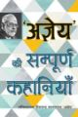 | Title: Ajneya Ki Sampurna Kahaniyan  Author: Agyeya  Publisher: Delhi: Rajpal & Sons, 2011  Call No.: 891.433 AJN  Acc. No.: 012383
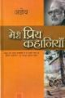 | Title: Meri priya kahaniyan  Author: Agyeya  Publisher: Delhi: Rajpal & Sons, 2012  Call No.: 891.43808 AGY  Acc. No.: 012434

Compiled by Library
24 May, 2019

