List of Books

By & on
RABINDRANATH TAGORE
(Available in the Library)

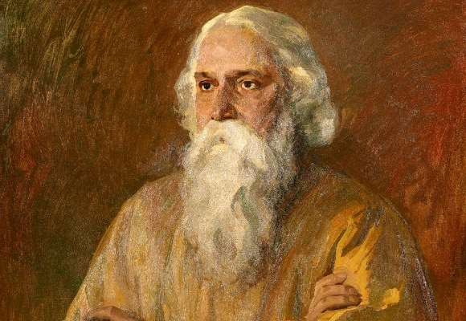

Compiled by Library
Indian Institute of Technology Gandhinagar

List of books by Rabindranath Tagore

- Tagore, R. (2010). Selected writings on literature and language. Chaudhuri, S. (Ed.) New Delhi: Oxford University Press.
891.109 TAG 015318
- Tagore, R. (2000). Selected short stories. New Delhi: Penguin Books. 891.4434 TAG 003745
- Tagore, R. (1994). Selected Short Stories. London: Penguin books. 891.4435 TAG 008336
- Tagore, R. (2002). Home and the world. New Delhi: Penguin book. 891.4436 TAG 019102
- Tagore, R. (2002). Home and the world. New Delhi: Wisdom Tree. 891.4436 TAG 007016
- Tagore, R. (2002). Mahatmaji and the depressed humanity: east and west. New Delhi: Rupa publications.
823.4434 TAG 009347
- Tagore, R. (2002). Rabindranath Tagore: selected short stories. New Delhi: Oxford university press
891.4435 TAG 022334
- Tagore, R. (2002). Selected short stories. New Delhi: Oxford University Press. 891.4435 TAG 017418
- Tagore, R. (2002). Selected Writings for Children. New Delhi: Oxford University Press. 891.448509 TAG 015317,022335
- Tagore, R. (2003). Rabindranath Tagore’s the home and the world: a critical companion.New Delhi: Permanent Black.
891.4434 TAG 001747
- Tagore, R. (2003). Vision of history: two essays. Shimla: Indian Institute of Advanced Study.
954 TAG 019724
- Tagore, R. (2004). Selected essays. New Delhi: Rupapublications.
891.444 TAG 014515
- Tagore, R. (2005). Grain of sand: Chokher bali. New Delhi: Penguin Books. 891.4434 TAG 008175
- Tagore, R. (2007). He (Shey). Chaudhuri, A. (Tr.) New Delhi: New York: Penguin Books. 891.4435 TAG 009663

- Tagore, R. (2008). Letters from a sojourner in Europe. Chakravarti, M. (Tr.). Roy, S. (Ed.) Kolkata: Visva-Bharati.
891.446 TAG 008459

- Tagore, R. (2009). Gora. Chakravarty, R. (Tr.). New Delhi: Penguin Books India. 891.4434 TAG 008177

- Tagore, R. (2009). Oxford India Tagore: selected writings on education and nationalism.
Gupta, U.D. (Ed.). New Delhi: Oxford university press.
320.54 TAG 022333

- Tagore, R. (2010). Rabindranath Tagore: selected poems. New Delhi: Oxford university press.
891.441 TAG 022336

- Tagore, R. (2010). Rabindranath Tagore: selected writings on literature and language.
Das, S. K. & Chaudhuri, S. (Eds.). New Delhi: Oxford University Press.
891.109 TAG 022337

- Tagore, R. (2010). Three novellas: nashtanir, dui bon, malancha. Ray, S. (Ed.). New Delhi: Oxford University Press.
891.4434 TAG 015350

- Tagore, R. (2010). Words of freedom: ideas of a nation. New Delhi: Penguin Books.
954.035 TAG 014311

- Tagore, R. (2011). Essential Tagore. Alam, F. & Chakravarty, R. (Eds.). Kolkata: Visva- Bharati.
891.448409 TAG 012234

- Tagore, R. (2011). Last poem. Basu, D. (Tr.). New Delhi: Harper collins.
891.441 TAG 012675

- Tagore, R. (2011). Rabindra chitravali: paintings of Rabindranath Tagore. Siva Kumar, R. (Ed.). Kolkata: Published by Pratikshan in association with Visva- Bharati, Santiniketan,Ministry of Culture, Govt. of India, New Delhi.
759.95414 TAG 014339-42

- Tagore, R. (2011). Ravindranatha Ṭaigora ki sampurṇa kahaniyam. New Delhi: Rajkamal Prakashan.
891.43301 TAG 017775- 77

- Tagore, R. (2012). Relationships: jogagog. Chaudhuri, S. (Tr.). Chaudhuri, S. (Ed.). New Delhi: Oxford University Press.
891.444 TAG 015309

List of books on Rabindranath Tagore

- Bhattacharya, S. (Tr.) (2009). Return of Khokababu: the best of Tagore. New Delhi: Harper Perennial.
891.4434 BHA 021915

- Central Book Trust. (1993). Remembering our leaders, vol. 4. New Delhi Childrens Book Trust.
954.0350924 REM CC0481

- Chaudhuri, S. (Ed.). (2012). Petrarch: the self and the world. New Delhi: Orient Blackswan.
851.1 CHA 015297

- Das Gupta, S., Cakrabarti, S. & Mathew, M. (2013). Radical Rabindranath: nation, family, and gender in Tagore’s fiction and films. New Delhi: Orient Blackswan.
891.441 DAS 015306

- Das, S. (2013). Architecture of Santiniketan: Tagore’s concept of space. New Delhi: Niyogi Books.
720.95414 DAS 019424

- Dasgupta, Subrata. (2007). Bengal renaissance: identity and creativity from Rammohun Roy to Rabindranath Tagore. New Delhi: Permanent Black
954.03 DAS 008460

- Dasgupta, U. (2004). Rabindranath Tagore: a biography. New Delhi: Oxford University Press.
891.4485 DAS 015304

- Dasgupta, U. (2013). Rabindranath Tagore: an illustrated life. New Delhi: Oxford University Press.
891.4414 DAS 015305

- Ghose, P. (Ed.). (2017). Einstein, Tagore, and the nature of reality. London: Routledge.
111 GHO 027436

- Gosling, D. L. (2007). Science and the Indian tradition: when Einstein met Tagore. London; New York: Routledge.
303.4830954 GOS 004196

- Kakar, S. (2013). Young Tagore: the making of a genius. New Delhi: Penguin Books India.
920.540 KAK 016241

- Pai, A. (2009). Rabindranath Tagore: India’s gentle torch-bearer. Mumbai: Amar Chitra Katha.
823.01 PAI CC0714

- Parekha, S. (2008). Tagore in Ahmedabad. Kolkata: Visva-Bhara.
891.4 PAR 008458

- Quayum, M. A. (Ed.). (2011). Poet and his world: critical essays on Rabindranath Tagore. New Delhi: Orient Blackswan.
891.4414 QUA 011232
- Roy, S., & Adhikari, S. (2014). Rabindranath Tagore: his world of art. New Delhi: Niyogi Books.
759.954 ROY 023466
- Sengupta, S., Roy, S. & Purakayastha, S. (Eds.). (2007). Towards freedom: critical essays on Rabindranath Tagore’s Ghare Baire: the home and the world. New Delhi: Orient Blackswan.
891.4336 SEN 015351
- Tagore, R., Rolland, R., & Guha, C. (2018). Bridging east and west: Rabindranath Tagore and Romain Rolland correspondence (1919-1940). New Delhi: Oxford University Press.
808.6 GUH0 027428
***
Updated on 8.05.2019

