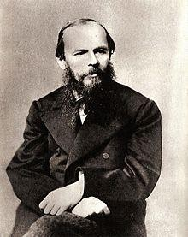

“
Author of the Week: Fyodor Dostoevsky

To live without Hope is to Cease to live.”

~ Fyodor Dostoevsky

Life and career:

Fyodor Mikhailovich Dostoevsky (11 November 1821 – 9 February 1881), was a Russian novelist, short story writer, essayist, journalist and philosopher.
Dostoevsky's literary works explore human psychology in the troubled political, social, and spiritual atmospheres of 19th-century Russia, and engage with a variety of philosophical and religious themes. His most acclaimed works include Crime and Punishment (1866), The Idiot (1869), Demons (1872) and The Brothers Karamazov (1880). Dostoevsky's oeuvre consists of 11 novels, three
novellas, 17 short stories and numerous other works. Many literary critics rate him as one of the greatest psychologists in world literature. His 1864 novella Notes from Underground is considered to be one of the first works of existentialist literature.

Dostoevsky was influenced by a wide variety of philosophers and authors including Pushkin, Gogol, Augustine, Shakespeare, Dickens, Balzac, Lermontov, Hugo, Poe, Plato, Cervantes, Herzen, Kant, Belinsky, Hegel, Schiller, Solovyov, Bakunin, Sand, Hoffmann, and Mickiewicz. His writings were widely read both within and beyond his native Russia and influenced an equally great number of later writers including Russians like Aleksandr Solzhenitsyn and Anton Chekhov as well as philosophers such as Friedrich Nietzsche and Jean-Paul Sartre. His books have been translated into more than 170 languages.

Honours:

- In 1956 an olive-green postage stamp dedicated to Dostoevsky was released in the Soviet Union, with a print run of 1,000 copies.
- A Dostoevsky Museum was opened on 12 November 1971 in the apartment where he wrote his first and final novels.
- A crater on Mercury was named after him in 1979, and so was a minor planet discovered in 1981.

To learn more about Fyodor Dostoevsky: https://en.wikipedia.org/wiki/Fyodor_Dostoevsky#Major_works

https://www.britannica.com/biography/Fyodor-Dostoyevsky

http://www.online-literature.com/dostoevsky/

List of books by Fyodor Dostoevsky available in our collection
1. | Title: Crime and punishment Author: Dostoevsky, Fyodor Publisher: Penguin Books Call No.: 891.733 DOS  Accession No. : 009995 | 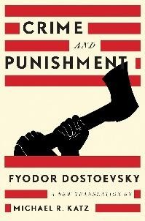
2. | Title: Brothers Karamazov: a revised translation, contexts, criticism  Author: Dostoevsky, Fyodor Publisher: W. W. Norton & Company Call No.: 891.733 DOS  Accession No. : 016032
3. | Title: Idiot  Author: Dostoevsky, Fyodor Publisher: Signet Classic Call No.: 891.733 DOS  Accession No. : 016137 | 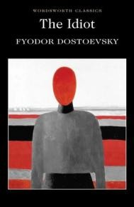
4. | Title: Winter notes on summer impressions  Author: Dostoevsky, Fyodor  Publisher: Northwestern University Press  Call No.: 891.78303 DOS  Accession No. : 024209 | 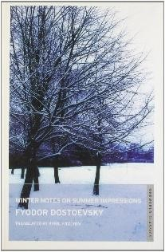
List of books on Fyodor Dostoevsky available in our collection
1. | Title: On Dostoevsky  Author: Anderson, Susan Leigh Publisher: Cengage Learning Call No.: 891.733 AND  Accession No. : 002447

Links to read more of Dostoevsky’s works:

https://www.jstor.org/action/doBasicSearch?Query=fyodor+dostoevsky&acc=on&wc=on&fc=off&group
=none

https://babel.hathitrust.org/cgi/ls?field1=ocr;q1=fyodor%20dostoevsky;a=srchls;lmt=ft

https://archive.org/search.php?query=Fyodor%20Dostoevsky

Compiled by Library

11.04.2019

