AUTHOR OF THE WEEK
DR. B.R. AMBEDKAR

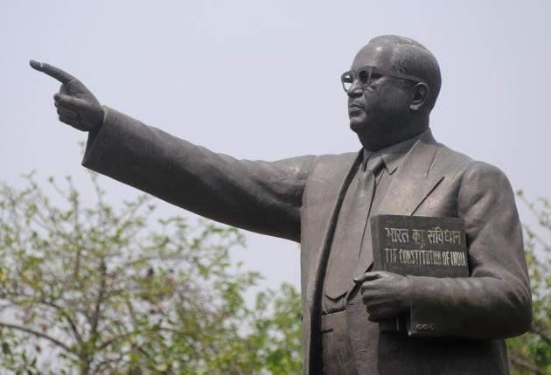

Compiled by LIBRARY
Indian Institute of Technology Gandhinagar

Books by and on Dr. B.R. Ambedkar
By Dr. B.R. Ambedkar
- Ambedkar, B. R. (2010). Words of freedom: ideas of a nation. New Delhi: Penguin Books.
954.035 AMB 014308

- Ambedkar, B. R., Anand, S., & Roy, A. (2014). Annihilation of caste: the annotated critical edition.
305.51220954 AMB 017981

- Ambedkar, B. R., Rathore, Akash Singh., & Verma, Ajay. (2011). The Buddha and his Dhamma a critical edition. New Delhi: Oxford Univ. Press.
294.34MB 014237

On Dr. B.R. Ambedkar
- Ambedkar, B. R., & Rodrigues, V. (2004). The essential writings of B.R. Ambedkar. New Delhi; Oxford: Oxford University Press.
305.51220954 ROD 011937

- Moon, Vasant., & Damle, Asha. (2002). Dr. Babasaheb Ambedkar. New Delhi: National Book Trust, India.
920.954 MOO CC0204

- Pavara, U., Muna, M., & Sonalkar, W. (2014). We also made history: women in the Ambedkarite movement. Chicago: University of Chicago Press
305.420954 PAW 022103

- Rege, S. S., Kadam, D., & Pai, A. (2014). Babasaheb Ambedkar: he dared to fight. Mumbai: Amar Chitra Katha.
823.01 PAI CC0547

- Rege, Sharmila. (2013). Against the madness of Manu B. R. Ambedkar’s writings on Brahmanical patriarchy. New Delhi: Navayana.
303.330811 REG 019267

- Omvedt, Gail. (1994). Dalits and the democratic revolution Dr. Ambedkar and the Dalit movement in colonial India. New Delhi: Sage.
322.40954 OMV 009629

- Omvedt, Gail. (2008). Ambedkar: towards an enlightened India. New Delhi; New York: Penguin.
954.35OMV 012084

- Omvedt, Gail. (2011). Understanding caste: from Buddha to Ambedkar and beyond. New

Delhi: Orient Blackswan Publishing.
305.5680954 OMV 011224

- Pai, Sudha., & Kumar, Avinash. (2014). Revisiting 1956: B.R. Ambedkar and states reorganisation. New Delhi: Indian Institute of Dalit Studies: Orient Blackswan. 320.45409045 PAI 019735

- Pati, B. (Ed.). (2014). Invoking Ambedkar: contributions receptions legacies. Delhi: Primus Books.
954.035 PAT 020095

- Thorat, Sukhdeo. (2009). B.R. Ambedkar: perspectives on social exclusion and inclusive policies. New Delhhi; Oxford: Oxford University Press.
305.5680954 THO 011936

- Varma, Amit (2011). Nehru-Ambeḍakara evaṃ samajika nyaya. Jayapura: Vanmaya Prakasana.
301.3427 VER 010475

- Verma, Babita. (2012). Gandhi, Ambedkar, dalit avam samajik nyaya. Jayapura: Aavishkar Prakashan.
301.185 VER 010419

- Vundru, R. S. (2018). Ambedkar, Gandhi and Patel: the making of India’s electoral system. New Delhi: Bloomsbury.
324.630954 VUN 025385

- Vyam, Durgabai. (2011). Bhimayana incidents in the life of Bhimrao R a m j i Ambedkar. New Delhi: Navayana.
741.5954 011169

- Vyam, D. (2011). Bhimayana: experiences of untouchability: incidents in the life of Bhimrao Ramji Ambedkar. New Delhi: Navayana Publisher.
741.4954 VYA 011522
Other links to read more of his works/about him: http://www.brambedkar.in/ http://drambedkarwritings.gov.in/content/ https://www.jstor.org/action/doBasicSearch?Query=b.r.+ambedkar
https://archive.org/search.php?query=ambedkar

https://babel.hathitrust.org/cgi/ls?field1=ocr;q1=ambedkar;a=srchls;lmt=ft&facet=format:%22Book%22
Compiled by LIBRARY Date: 15th April 2019

