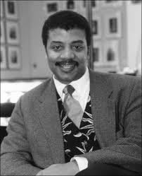
Author of the Week: Neil deGrasse Tyson

“The good thing about science is that it’s true whether or not you believe in it.”

Life and career:

Neil deGrasse Tyson is an American astrophysicist, author, and science communicator. Since 1996, he has been the Frederick P. Rose Director of the Hayden Planetarium at the Rose Center for Earth and Space in New York City. The center is part of the American Museum of Natural History, where Tyson founded the Department of Astrophysics in 1997 and has been a research associate in the department since 2003.
Tyson studied at Harvard University, the University of Texas at Austin and Columbia University. From 1991 to 1994 he was a postdoctoral research associate at Princeton University. In 1994, he joined the Hayden Planetarium as a staff scientist and the Princeton faculty as a visiting research scientist and
lecturer. In 1996, he became director of the planetarium and oversaw its $210 million reconstruction project, which was completed in 2000.From 1995 to 2005, Tyson wrote monthly essays in the "Universe" column for Natural History magazine, some of which were later published in his books Death by Black Hole (2007) and Astrophysics for People in a Hurry (2017). During the same period, he wrote a monthly column in StarDate magazine, answering questions about the universe under the pen name "Merlin". Material from the column appeared in his books Merlin's Tour of the Universe (1998) and Just Visiting This Planet (1998). Tyson served on a 2001 government commission on the future of the U.S. aerospace industry, and on the 2004 Moon, Mars and Beyond commission. He was awarded the NASA Distinguished Public Service Medal in the same year. From 2006 to 2011, he hosted the television show NOVA ScienceNow on PBS. Since 2009, Tyson has hosted the weekly podcast StarTalk. A spin-off, also called StarTalk, began airing on National Geographic in 2015. In 2014, he hosted the television series Cosmos: A Spacetime Odyssey, a successor to Carl Sagan's 1980 series Cosmos: A Personal Voyage. The U.S. National Academy of Sciences awarded Tyson the Public Welfare Medal in 2015 for his "extraordinary role in exciting the public about the wonders of science."

Awards and achievements:

- 2001 Medal of Excellence, Columbia University, New York City
- 2004 NASA Distinguished Public Service Medal
- 2005 Science Writing Award
- 2007 Klopsteg Memorial Award winner
- 2009 Douglas S. Morrow Public Outreach Award from the Space Foundation for significant contributions to public awareness of space programs
- 2009 Isaac Asimov Award from the American Humanist Association
- 2014 Critics' Choice Television Award for Best Reality Show Host
- 2014 Dunlap Prize
- 2015 Public Welfare Medal from the National Academy of Sciences
- 2015 Cosmos Award, Planetary Society
- 2017 Hubbard Medal, National Geographic Society
- 2017 Stephen Hawking Medal for Science Communication, Starmus
- 2017 Grammy Award for Best Spoken Word Album nomination for Astrophysics for People in a Hurry

To know more about the author:
- https://en.wikipedia.org/wiki/Neil_deGrasse_Tyson#Awards
- https://www.haydenplanetarium.org/tyson/
- https://www.youtube.com/watch?v=UFzpAh-x_IY

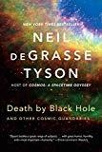Books by Neil deGrasse Tyson

1. | Title: Death by black hole and other cosmic quandaries  Author: Tyson, Neil Degrasse Publisher: W.W. Norton and Company Call No.: 523.8875 TYS  Accession No. : 020510
2. | Title: Pluto files: the rise and fall of America’s favorite planet  Author: Tyson, Neil Degrasse Publisher: W.W. Norton and Company Call No.: 523.4922 TYS  Accession No. : 020514 | 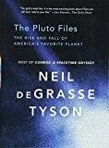
3. | Title: Space chronicles: facing the ultimate frontier Author: Tyson, Neil Degrasse and Lang, Avis (Ed.) Publisher: W.W. Norton and Company  Call No.: 629.40973 TYS  Accession No. : 020513 | 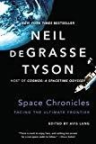
4. | Title: Universe down to earth Author: Tyson, Neil Degrasse Publisher: Columbia University Press Call No.: 520 TYS  Accession No. : 020737 | 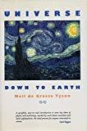
5. | Title: Origins: fourteen billion years of cosmic evolution Author: Tyson, Neil Degrasse and Goldsmith, Donald Publisher: W.W. Norton and Company  Call No.: 523.1 TYS  Accession No. : 020781 | 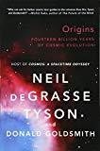
6. | Title: Just visiting this planet: Merlin answers more questions about everything under the sun, moon, and stars  Author: Tyson, Neil Degrasse and Tyson, Stephen J. (Ill.)  Publisher: Doubleday  Call No.: 520 TYS  Accession No.: 021505 | 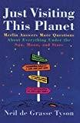

7. | Title: Welcome to the universe: an astrophysical tour  Author: Tyson, Neil Degrasse Publisher: Princeton University Press Call No.: 523.1 TYS  Accession No. : 024202 | 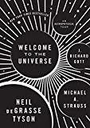

Compiled by Library, IIT Gandhinagar
15.03.2019

