**Author of the Week: Ramachandra Guha**

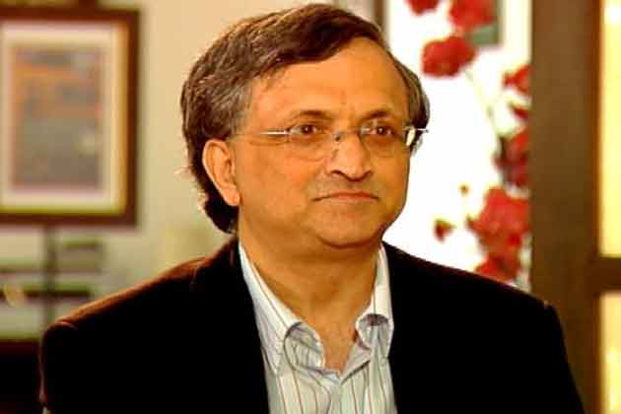

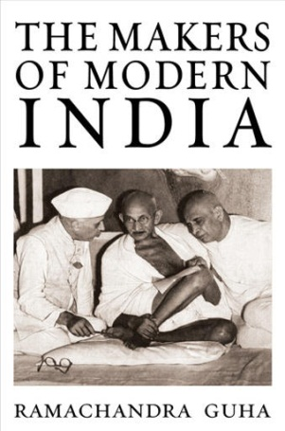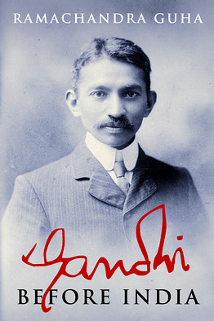Ramachandra Guha born 29 April 1958 is an Indian historian and writer whose research interests include environmental, social, political and cricket history. He is also a columnist for The Telegraph and Hindustan Times A regular contributor to various academic journals, Guha has also written for The Caravan and Outlook magazines. For the year 2011–2012, he held a visiting position at the London School of Economics and Political ScienceHis newest book is Gandhi Before India (2013), the first part of a planned two-volume biography of M. K. Gandhi. His large body of work covering a wide range of fields and yielding a number of rational insights has made him a significant figure in Indian historical studies, and Guha was valued as one of the major historians of the late twentieth and early twenty first centuries.

Awards and recognition

* His essay, "Prehistory of Community Forestry in India", was awarded the Leopold-Hidy Prize of the American Society for Environmental History for 2001.
* "A Corner of a Foreign Field" was awarded the Daily Telegraph Cricket Society Book of the Year prize for 2002.
* The US magazine Foreign Policy named him as one of the top 100 public intellectuals in the world in May 2008
* Padma Bhushan for 2009, India's third highest civilian award
* 2011 Sahitya Akademi Award for India after Gandhi
* In 2014, Guha was awarded an honorary Doctor of Humanities by Yale University
* Fukuoka Asian Culture Prize, 2015

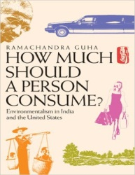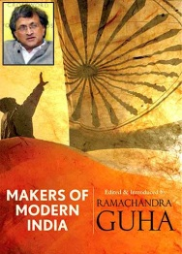

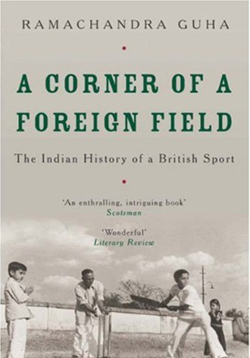

1. Arnold, David. & Guha, Ramachandra. (1995). *Nature, culture, imperialism : essays on the environmental history of South Asia*. New Delhi: Oxford University Press.

363.700954 NA 013395

1. Gadgil, Madhav. & Guha, Ramachandra. (1992). *This fissured land : an ecological history of India* (2nd ed). Delhi : Oxford University Press.

333.00954 GAD 013273

1. Guha, Ramachandra. (2016). *Democrats and dissenters*. New Delhi: Penguin Random.

335.5 GUH 024224

1. Guha, Ramachandra. (2000). *Environmentalism: a global history*. New York: Longman Publishing.

363.705 GUH 013694

1. Guha, Ramachandra. (2000). *Unquiet woods: ecological change and peasant resistance in the Himalaya*. New York: University of California Publication.

333.7509542 GUH 019969& 020020

1. Guha, Ramachandra. (2007). *India after Gandhi : the history of the world`s largest democracy*. New Delhi: Picador India.

954.04 GUH 009768, 010997& 010998

1. Guha, Ramachandra (2010). *Makers of modern India*. New Delhi: Penguien Groups/ Viking.

954.0099 MAK 008342-008355

1. Guha, Ramachandra. (2013). *Gandhi before India*. New Delhi: Penguin Books.

954.035092 GUH 024184, 016196 & 016197

1. Guha, Ramachandra. & Parry, J. P. (2011). *Institutions and inequalities: essays in honour of Andre Beteille*. New Delhi: Oxford University Press.

305.0954 INS 017086

1. Guha, Ramachandra. (2005). *Ramachandra guha omnibus: The Unquiet Woods, Environmentalism, Savaging the Civilized*. New Delhi: Oxford University Press.

333.7509542 GUH 011893

**\*\*\*\*\*\***

**Compiled by Library**

**11th JAN. 2017**